SCIENCE REPORT

Atom Reactions in Electrolysis of NaCl Solution as an Electrolyte with Graphite Electrodes

Ibadurrahman Labib Ulya
2024 - 2025

BAB 1

Introduction

Atom. The tiny matter that makes up everything. Includes elements in the periodic table. Existing chemical reactions will definitely involve atoms in the process. From this chemical process, the reacting atoms will usually undergo changes and produce new substances. Every chemical reaction involves changes in the arrangement of electrons around the atomic nucleus, leading to the formation or breaking of atomic bonds. There are lots of chemical reactions out there to produce new substances. Some react by changing temperature or pressure, and others use electricity. A chemical reaction that changes a starting substance by utilizing electricity is called electrolysis.

The reactions that occur in the electrolysis process usually occur at the cathode and anode. Namely electrodes that carry electricity. The electrolysis process requires a liquid called an electrolyte, which is a liquid that can contain electricity. Each type of electrolyte used will produce a different final reaction. The reason for choosing electrolysis is because the reaction produced at the electrode is very clear. Because the electrodes in electrolysis will immediately produce a reaction as soon as electricity is applied. In this way, the observation process can be carried out quickly, so that any modifications or adjustments can be implemented immediately to achieve concrete results.

Electrolysis will take place using graphite as an electrode. The use of graphite as an electrode was chosen because of its inert nature and ability to conduct electric current without directly participating in chemical reactions, thus allowing the observation of purer electrolyte reactions.

In this study paper, the electrolysis process will be used to observe atomic reactions in NaCl (salt) solution, as well as changes in atomic mass. By varying parameters such as solution concentration and current intensity, we can predict the amount of product produced as well as the time required for the reaction to occur.

Problem identification
- How does NaCl electrolysis work?
- What are the important things that must be considered in the NaCl electrolysis process?
- What is produced by the NaCl electrolysis process?
- What chemical reactions or atomic changes occur during the NaCl electrolysis process?
- Does the chemical reaction of NaCl electrolysis change the atomic mass?
- Does the amount of NaCl(salt) affect electrolysis(NaCl)?
- Will the surface exposed to the electrolyte solution affect the efficiency of NaCl electrolysis?
- Does battery voltage/amperage affect electrolysis?

Problem limitation
This study will focus on observing chemical reactions that occur in electrolysis, especially reactions that change atoms in terms of splitting or joining. As well as validating the law of conservation of atomic mass. Several variables can affect NaCl electrolysis. Such as the concentration of salt (NaCl) and water (H2O), battery voltage and amperes etc. which affects the rate of reaction speed, the number of reactions that occur, etc. And will focus on proving the reaction that occurred, more specifically proving that the electrolysis process actually produces hydrogen gas, because hydrogen gas is a flammable gas so it is easy to prove.

Hypothesis
- If the NaCl (salt) solution is reacted by electrolysis, it will produce Hydrogen gas, Chlorine gas, and increase the NaOH level in the electrolyte.
- If you expose more of the electrode surface to the NaCl (salt) solution, more reactions will occur at the cathode and anode.
- If the battery voltage/ampere is increased it will affect the reaction speed.
- If the concentration of the NaCl (salt) solution is 10-30% of the total water, the reaction that occurs will not cause heat or corrosion which can damage the electrode. The reaction that occurs may not be very fast compared to a lot of salt, but the reaction that occurs will still be smooth and can produce many more reactions compared to concentrations with a lot of salt.

Objective and benefits
aims to study the atomic reactions that occur during the electrolysis process in sodium chloride (NaCl) solution using graphite electrodes. The main aim of this research is to understand the atomic changes that occur in solutions, as well as how the law of conservation of mass is applied in this process. By utilizing electrolysis, we can directly observe the formation of chemical products such as hydrogen and chlorine, as well as the decrease in NaCl concentration.
This research provides benefits in understanding the basics of chemical and electrochemical reactions through simple experiments that can be carried out in a short time. By focusing on atomic reactions in NaCl electrolysis, we can learn about the law of conservation of mass directly by observing the changes that occur in the solution and the products produced. This experiment is also useful for developing skills in conducting and analyzing simple chemical experiments.

BAB 2

Theoretical literacy
Electrolysis NaCl
Electrolysis, process by which electric current is passed through a substance to effect a chemical change. The chemical change is one in which the substance loses or gains an electron (oxidation or reduction). The process is carried out in an electrolytic cell, an apparatus consisting of positive and negative electrodes.(Encyclopaedia Britannica)
During the electrolysis, hydrogen and chloride ions are removed from solution whereas sodium and hydroxide ions are left behind in solution. This means that sodium hydroxide is also formed during the electrolysis of sodium chloride solution. This process is carried out on an industrial scale using sea water to produce hydrogen gas, chlorine gas and sodium hydroxide solution. BBC. (n.d.)
Electrode & NaCl Solution
Two electrical conductors (electrodes) are immersed in the liquid to be electrolyzed. These electrodes are often made of an inert material such as stainless steel, platinum, or graphite. The liquid to be electrolyzed must be able to conduct electricity, and so it is usually an aqueous solution of an electrolyte or a molten ionic compound.(Encyclopaedia Britannica)
Metal ions and hydrogen ions are positively charged. Whether you get the metal or hydrogen during electrolysis depends on the position of the metal in the reactivity series:
- the metal will be produced if it is less reactive than hydrogen
- hydrogen will be produced if the metal is more reactive than hydrogen
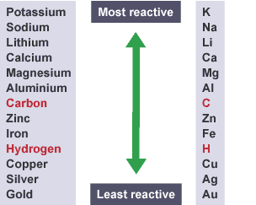
Figure caption,
The reactivity series of metal – carbon and hydrogen are not metals, but they are shown for comparison
For example, the electrolysis of copper(II) chloride solution produces copper at the negative electrode. However, the electrolysis of sodium chloride solution produces hydrogen. Note that the electrolysis of sodium chloride solution produces chlorine gas and hydrogen gas but also leaves a solution of sodium hydroxide as well. BBC. (n.d.)
The table summarises some of the elements you should expect to get during electrolysis.
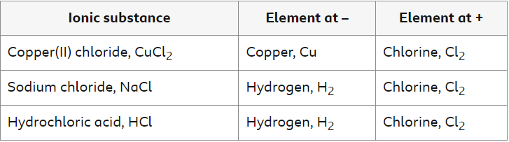
When aqueous solutions of ionic compounds are electrolyzed, the anode and cathode half-reactions may involve the electrolysis of either water species (H₂O, H⁺, OH–) or solute species (the cations and anions of the compound). As an example, the electrolysis of aqueous sodium chloride could involve either of these two anode reactions:
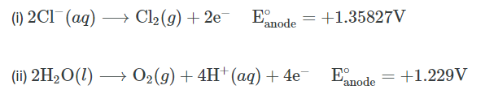
The standard electrode (reduction) potentials of these two half-reactions indicate water may be oxidized at a less negative/more positive potential (–1.229 V) than chloride ion (–1.358 V). Thermodynamics thus predicts that water would be more readily oxidized, though in practice it is observed that both water and chloride ion are oxidized under typical conditions, producing a mixture of oxygen and chlorine gas. (lumen)
Conservation of Atom Mass
The Law of Conservation of Mass is a fundamental concept in chemistry, stating that mass in an isolated system is neither created nor destroyed by chemical reactions or physical transformations. According to the law, the mass of the reactants in a chemical reaction equals the mass of the products. Further, the number and type of atoms in a chemical reaction is the same before and after the reaction.
The law holds true in chemical reactions under ordinary conditions. This is because chemical reactions only involve electrons and do not affect the identities of the parts of the atom. Anne Helmenstine, (2023)
However, the Law of Conservation of Mass does not hold in nuclear reactions, where mass can convert into energy (and vice versa) according to the principle of mass-energy equivalence as proposed by Einstein in the theory of relativity. This conversion occurs in nuclear fission and fusion reactions and some forms of radioactive decay. Anne Helmenstine, (2023)

BAB 3

Variables
Independent Variable
- Water & salt concentration
- The surface area of ​​the electrode exposed to the electrolyte
- Battery voltage & Amperes
Dependent Variable
- The number of reactions that occur
- The speed of the reaction that occurs
- Heat & electrode corrosion

Process iteration
The model we made for this research uses carbon electrodes as the anode and cathode, with a 9v and 2 ampere battery. NaCl (salt) solution is used as an electrolyte in this electrolysis process. We use plastic tubes for electrolysis. The electrodes are stuck from the bottom of the plastic tube, which stands on cardboard with a hole cut in it for electrical access. Each electrode is given a hollow tube outside the tube, to take reaction gasses. This can be useful to prove the reactions that occur at the anode and cathode, because at the cathode more reactions will occur. The way to prove this is by drowning it in a container filled with water, then we count the bubbles from the cathode hose and the anode hose. We also made antenna-shaped electrodes to prove that the exposed surface of the electrode can influence the number of reactions that occur. We also made the model twice. one is powered by a 9v, 2 ampere battery and the other is 12v, 2 ampere. In this experiment what was observed was the speed of the bubbles produced, as well as how quickly the electrode broke.
In electrolysis reactions the substances produced are very wide, depending on the conditions and experimental environment. Specifically, in this electrolysis experiment, there are a total of 4 reactions.
At the cathode (negative electrode), water is reduced to produce hydrogen gas, as sodium ions are less likely to be reduced than water in an aqueous solution:
2H₂​O+2e−→H₂​(g)+2OH−
Hydrogen gas bubbles form at the cathode, and hydroxide ions are released into the solution.
At the anode (positive electrode), chloride ions from NaCl are oxidized to produce chlorine gas: 2Cl−→Cl₂​(g)+2e−
Chlorine gas bubbles form at the anode.
The sodium ions (Na⁺) from the NaCl solution remain in the solution and combine with the hydroxide ions (OH⁻) produced at the cathode to form sodium hydroxide: Na++OH−→NaOH(aq)
This results in a basic solution of sodium hydroxide.
The hydrogen gas (H₂) produced at the cathode comes into contact with the oxygen (O₂) present in the air inside the hose, they will react to form water: 2H2​(g)+O2​(g)→2H2​O(l)
This reaction occurs as soon as hydrogen and oxygen meet, even without an external spark or heat. It’s a slow reaction, producing water vapor rather than liquid water immediately.

BAB 4

Result, Analysis
It could be said that this experiment has succeeded in reacting atoms from existing molecules into new substances. With this we can also validate the law of conservation of atoms based on the reactions that occur. We will compare atomic molecules before the reaction and after the reaction.
I will use the benchmark of 2 molecules of NaCl and 2 molecules of H2O to prove the conservation of atoms. It takes 2 molecules as a benchmark because in the NaCl electrolysis process hydrogen gas and chlorine gas are formed from 2 hydrogen atoms and 2 chlorine atoms, and also OH- ions need 2 H2O molecules to form. Now let's look at the electrolysis reaction once again.
Reaction at the Cathode (Negative):
2 H₂O molecules decompose to produce 2 H₂ molecules and 2 OH⁻ ions.
- Reaksi: 2H2O(l)+2e−→H2(g)+2OH−(aq)2H_2O (l) + 2e⁻ \rightarrow H_2 (g) + 2OH⁻ (aq)2H2​O(l)+2e−→H2​(g)+2OH−(aq)

Reaction at the Anode (Positive):
2 NaCl molecules produce 1 Cl₂ molecule from 2 Cl⁻ ions.
- Reaksi: 2Cl−(aq)→Cl2(g)+2e−2Cl⁻ (aq) \rightarrow Cl_2 (g) + 2e⁻2Cl−(aq)→Cl2​(g)+2e−
Number of Atoms Before Reaction:
2 NaCl molecules give:
Na: 2
Cl: 2
2 molecules H₂O (water) gives:
H: 4 (2 molekul H₂O x 2 atom H per molekul)
O: 2
Number of Atoms After Reaction:
H₂ (gas hidrogen):
H: 2 (dari 1 molekul H₂)
Cl₂ (gas klorin):
Cl: 2 (dari 1 molekul Cl₂)
2NaOH (natrium hidroksida):
Na: 2
O: 2 (dari 2 ion OH⁻)
H: 2 (dari 2 ion OH⁻)
Initial Atom Total:
Na: 2
Cl: 2
H: 4
O: 2
Final Atom Total:
Na: 2
Cl: 2
H: 4 (2 dari H₂ dan 2 dari 2 OH⁻)
O: 2 (dari 2 OH⁻)

Apart from successfully proving the law of conservation of atoms, I also succeeded in proving that the cathode produces more reactions. In this experiment I also tried to make an antenna-shaped electrode in the hope that more reactions would occur, and it turned out that more reactions occurred compared to just an ordinary rod electrode. I also tried to do electrolysis with different voltages, namely 9 and 12 volts. Because of course the eye alone cannot calculate the increased reaction speed, so I only compared it with the visual results that the naked eye can digest. That is how many seconds it takes to break the carbon electrode. At 9 volts the electrode broke after using electrolysis for 1 hour 30 minutes, while the 12 volt electrode broke when using electrolysis for 1 hour. And also I kept hydrogen gas in a balloon to prove that the electrolysis process of NaCl actually produces a chemical reaction on the atoms of the molecule.

Broken Electrode From 9 Volt Testing hydrogen gas with fire
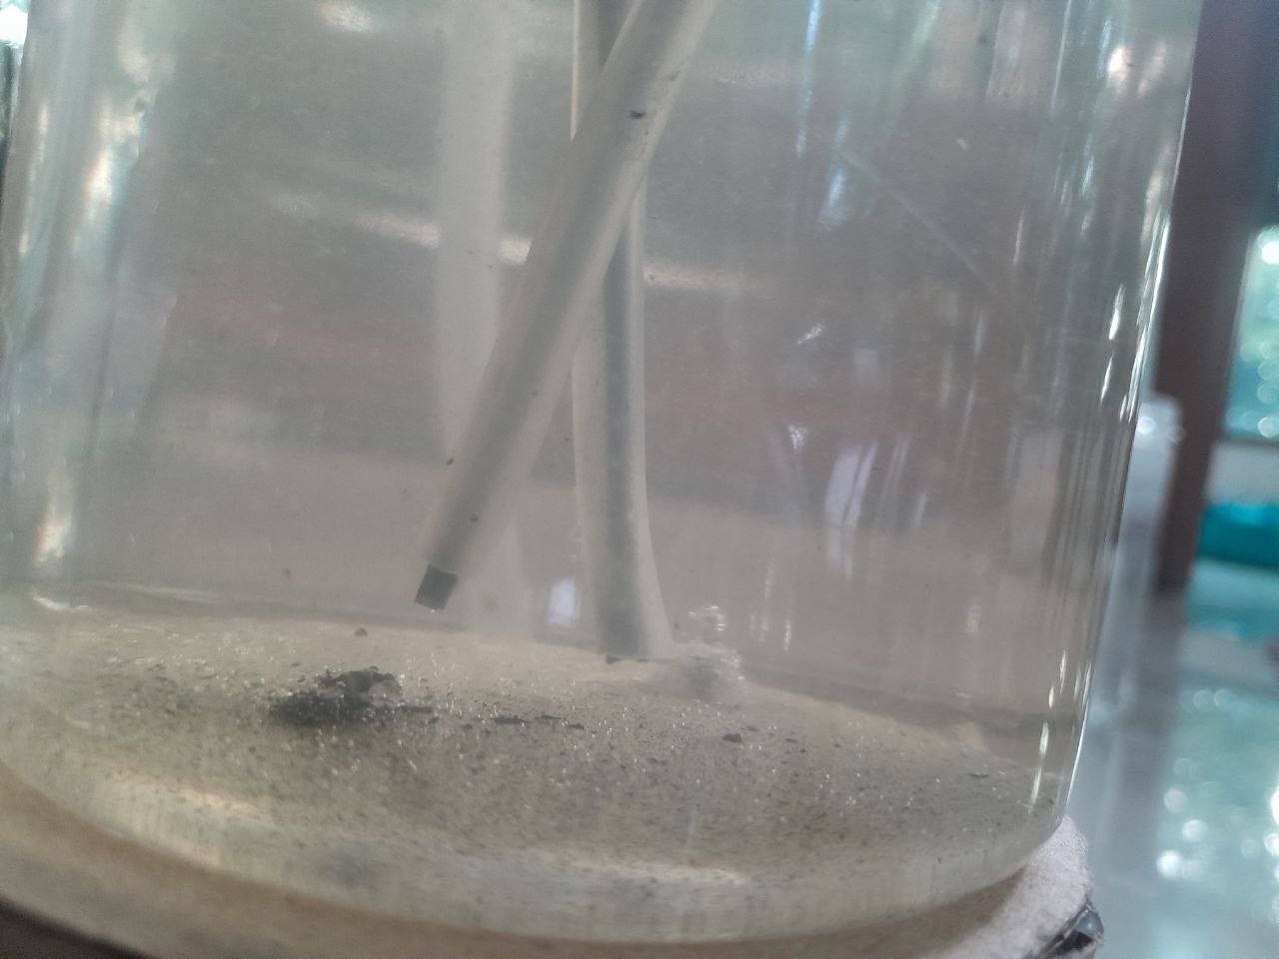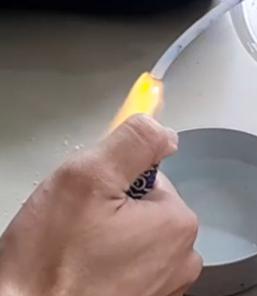
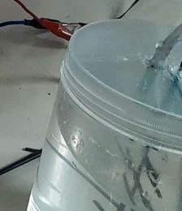
Reaction From single electrode Reaction From antenna like electrode
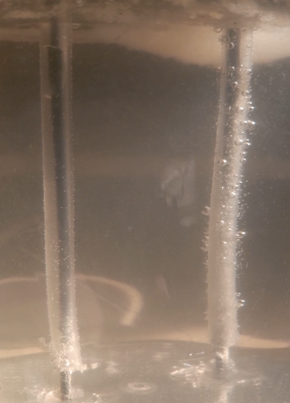

Theoretical analysis
This theoretical analysis of the literature regarding NaCl electrolysis provides a clear picture of the basic process of electrolysis, the type of electrode used, and the reactions that occur in the NaCl solution. The electrolysis process basically involves the flow of electric current through a substance to cause chemical changes, where these changes are the transfer of electrons which leads to oxidation or reduction. Electrolysis of a NaCl solution typically produces hydrogen and chlorine gases as well as sodium hydroxide solution.

For electrodes, the material used is usually inert, such as graphite or stainless steel, because it does not react with the solution. When an electric current is applied, positive ions such as sodium and negative ions such as chlorine move towards their respective electrodes (sodium towards the cathode and chlorine towards the anode). Here, sodium does not react directly because it is more reactive than hydrogen, so what happens is the production of hydrogen gas at the cathode. Meanwhile, the chlorine ions at the anode will oxidize to form chlorine gas.

In this process, it is important to understand that in addition to producing hydrogen and chlorine gas, a sodium hydroxide solution is also formed which remains in the solution. This occurs because sodium ions and hydroxide ions (OH-) remain in the solution after the chloride ions (Cl-) are removed through oxidation.

Based on the concept of the Law of Conservation of Mass, we know that the mass of substances before and after the electrolysis reaction will remain the same. Even though substances change form or phase (from ions in solution to gasses such as hydrogen and chlorine), the number of atoms present remains the same, and no mass is lost during the reaction. This is in accordance with the principle that chemical reactions only involve electrons, not parts of the atomic nucleus such as protons or neutrons, so that the identity of the atom is maintained.

In practical applications, NaCl electrolysis is widely used in industry to produce important materials such as hydrogen gas, chlorine and sodium hydroxide which are basic ingredients in various industrial processes, including the manufacture of plastics and other chemical products. This reaction also shows how the electrolysis process is an efficient method for separating elements from a chemical compound through the use of electric current.

However, in practice, although thermodynamics shows that water can be oxidized more easily than chloride ions, in reality both substances can be oxidized, so that both oxygen and chlorine gas can be formed. The actual reaction depends on the specific conditions during electrolysis, such as voltage and solution concentration.

Bab 5

Conclusion
Electrolysis works by providing a chemical reaction using electricity. In the electrolysis process, electrodes are something that must be paid attention to, because without electrodes the reaction will not take place. If the electrode reacts continuously, it will eventually erode and break. Therefore, electrode selection is also important in electrolysis. Electrolysis with NaCl solution produces substances such as, Chlorine (Cl₂), Hydrogen (H₂), Sodium hydroxide (NaOH). In the case of this experiment there is another reaction that occurs. After observing for a while, you can see that water (H₂O) is also formed from the reaction 2H₂ + O₂. In the NaCl electrolysis process, the atomic mass does not change at all. The amount of salt in the electrolysis process can actually affect the reaction. Because there could be a possibility for OH- ions to react at the anode if the NaCl content is very little or non-existent. The surface of the electrode that is exposed to the NaCl solution influences the number of reactions that occur. Pembuktian voltase baterai yang berpengaruh juga berhasil, dengan menghitung waktu elektroda patah di dua voltase berbeda. You could say that the higher the voltage, the more easily the electrode breaks, although I can't confirm the difference in reaction.

Future suggestions
Electrode Optimization: Try a more durable electrode material (such as stainless steel or platinum) to prevent damage.
Hydrogen Collection System: Replace balloons with gas bladders or more practical containers for storing hydrogen.
Precision Measurement: Use gas sensors or other methods to accurately measure hydrogen volume.

APPENDIX

Reference
Britannica, The Editors of Encyclopaedia. "electrolysis". Encyclopedia Britannica, 12 Jul. 2024, https://www.britannica.com/science/electrolysis. Accessed 5 September 2024.
BBC. (n.d.). Electrolysis of ionic solutions. https://www.bbc.co.uk/bitesize/guides/zv2yb82/revision/2

Helmenstine, A. (2023). Law of Conservation of Mass. https://sciencenotes.org/law-of-conservation-of-mass/#google_vignette

Lumen. (n.d.). Electrolysis. https://courses.lumenlearning.com/chemistryformajors/chapter/electrolysis/

