SCIENCE REPORT

Brushed DC Motor as Energy Transfer and Energy Change.

Ibadurrahman Labib Ulya
2024 - 2025

BAB 1

Introduction
Energy. something that is inherent in human life. Energy has a long history with humans. But it is this energy that accompanies humans throughout their history. To explain energy simply, the essence of energy is an ability that can do work. The law of conservation says energy can neither be destroyed nor created. However, energy can be transferred or changed in form. Of the many things that can change the form of energy and transfer it, I will use a Brushed DC (Direct Current) Motor, or you could say an electric motor as energy transfer and energy change.
Electric motors themselves are something that is also inherent in our lives. I'm sure there are at least some electric motors in use in your house, such as fans, computers, drones and many other electronic items. DC electric motors are powered by DC electricity, which means that this energy source is transferred and changed until it becomes a rotation as an output that originates from electrical energy.
We can see the DC motor's oscillating voltage waves. And these waves influence each other with the DC motor output, namely the rotation speed. And also DC motors with their energy changes occur very quickly, so they are easy to observe. The remaining energy will usually appear after a few seconds when the DC motor is turned on.

Problem identification
- A DC motor transfers what energy?
- Is there a change in the form of energy in a DC Motor
- How to visualize transfer energy in wave form?
- What waves are formed during energy transfer?
- What factors influence waves?
- What factors influence energy transfer efficiency?
- Can coil windings affect energy?
- How to illustrate the waves in a DC Motor?
- Are the 9v and 12v electric current waves in DC motors different?

Problem limitation
This research or experiment will focus and try to illustrate the transfer of energy in a DC motor into waves. The DC motor that is made will be focused on replicating how a real DC motor works. Therefore, it is hoped that the results of this model can replicate DC motor parts such as the commutator, brushes, rotor and stator. With this DC motor replica, changes in the energy contained in the DC motor will be observed. All energy changes or energy transfers in the DC motor model are the focus of this research. And how waves such as electric current and electromagnetic waves are related to the energy transfer output of a DC motor. However, what is focused here is the electric current waves that affect the DC motor output

Hypothesis
If there are more turns in the coil, the magnetic field will be greater, which will make the DC motor spin faster.
If a DC motor is given energy in the form of electricity, the DC motor will convert it into mechanical energy, which can be seen by giving the DC motor an electric current, which then the DC motor shaft will rotate.

Objective and benefits
The main objective of this research is to create a brushed DC motor model that can show the energy transfer process, as well as energy changes in the energy transfer. And we will also see how the electric current waves in a DC motor affect the output of the DC motor, such as the rotational speed output of the DC motor. Another objective is to compare the electric current waves of DC motors at voltages of 9v and 12v.
With an illustration of waves from a DC motor, analysis will become easy, where you can see how certain variables affect the wave shape and vice versa. In this way, not only does the understanding of transfer energy increase but also the understanding of how there are waves in each transfer energy.

BAB 2

Theoretical literacy

Energy Change & Transfer
A Direct Current (DC) motor is a motor that turns energy from a direct current and turns this into mechanical energy. The first DC motor was developed around the 1830’s-1840s. They were commercially unsuccessful, because these motors were battry powered and batteries were still very expensive and the quality was low. (magneticinnovations.com. n.d)

The DC motor converts electrical energy into mechanical power by which the electricity is supplied to the DC motor, due to the presence of a magnetic field, torque is produced and the shaft is rotated. (Vedantu. 2024)

Sine Wave
The general form of the sinusoidal function is y = A sin (B(x-C)) + D. In this equation, the amplitude is A, the period is 2pi / |B|, the phase shift is C, and the vertical shift is D.(Hoyland S. 2023)
The amplitude of a sinusoidal function measures its vertical width. It can be calculated either (i) by calculating the vertical distance between a peak and the midline (or between the midline and a trough) or (ii) by calculating the vertical distance between the peaks and troughs and dividing that distance by 2. In the graph of 𝑦=sin⁡𝑥, the amplitude is 1.(Hoyland S. 2023)
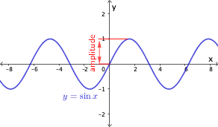
The period is the length of one cycle. That is, it is the horizontal distance between each repetition. It is often easiest to find the period by calculating the horizontal distance between two peaks or the horizontal distance between two troughs. In the graph in FIg. 4, the period is 2𝜋 since the sine function repeats every 2𝜋 (Hoyland S. 2023)
.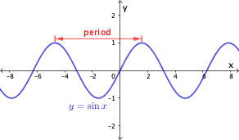
DC Motor Wave
Assuming that the motor operates under No Load conditions, at this stage, the DC motor only needs very little Torque to adjust the friction and winding loss. As a result, the DC motor extracts less Current. The inverse electromagnetic field and the Current in a DC motor are mutually dependent, so the value of the inverse electromagnetic field will decrease with the decrease of the electric Current. At this stage, the magnitude of the counter electromagnetic field is approximately equal to the Voltage provided.(kinmore. 2019)
When a sudden load is applied on the shaft of the DC motor, the DC motor slows down. As the Speed of the DC motor decreases, the amplitude of the anti-electromagnetic field will also decrease. A small inverse electromagnetic field will extract a large Current from the power supply. The armature Current induces a greater Torque in the armature, which is needed in a DC motor. As a result, the DC motor runs continuously at a new Speed.(kinmore. 2019)
The load on the DC motor is suddenly reduced. In this case, the drive Torque on the DC motor is greater than the load Torque. The driving Torque increases the Speed of the DC motor, which also increases the anti-electromagnetic field. The armature Current is reduced by the high value of the inverse electromagnetic field. Thus, the armature Current value produces a drive Torque, which is equal to the load Torque. As a result, the DC motor will rotate uniformly at the new Speed. (kinmore. 2019)
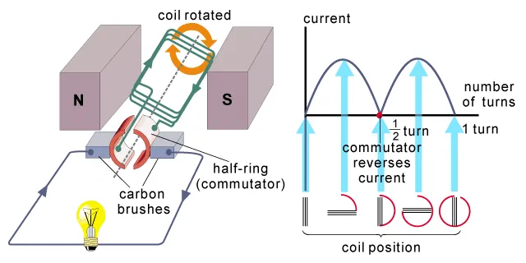

BAB 3

Variables
Independent Variable
- Cable winding
- Voltage
Dependent Variable
- Spin speed
- Electric current waves
Control Variable
- Electromagnetic fields

Process iteration
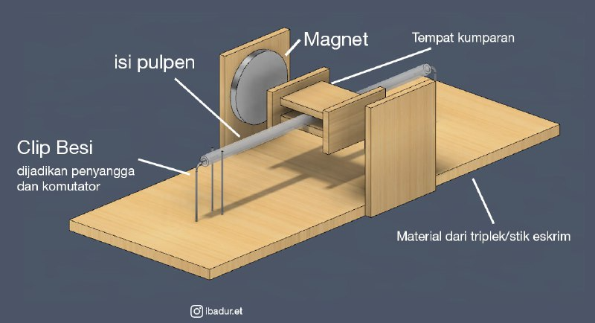
In the models made, the most important thing to pay attention to is the DIY aspect. where the brushed DC motor model must be made with tools and materials that are easy to find and cheap to buy. The idea beside this is a model whose idea has been developed further so that it looks like this.

In this model, the contents of the pen that have been cleaned are used as the motor shaft. This motorbike shaft is supported by an iron clip so that it remains in place and can rotate. In the middle of the motor shaft there are several plywood boards that are glued to wind the coil. The coil will use an enamel cable with a diameter of 0.5 mm. This is because the DC motor experiment was carried out with a voltage of 9v - 12v with 2 amperes or less. Therefore, you need to pay attention to the thickness of the enamel cable so that the coil is not easily damaged. Plywood was also chosen as the coil holder because the material is quite heat resistant compared to ordinary plastic.
When making a coil, at the beginning of the winding, leave an enamel cable that has been peeled off using sandpaper. At the end of the winding, you are also left with an enamel cable whose coating has been peeled off. This is done so that it resembles a commutator mechanism where the enamel cable can carry electricity using an iron clip that is connected to an electricity source. The enamel cable in the commutator section is installed at an angle of 30 degrees. Because if it is installed at the same degree on the coil, the DC motor can stop in the middle of the road when rotating.
On the right and left sides of the coil there are permanent magnets parallel to the coil. If it is not aligned it will affect how this DC motor model rotates. Then the mechanism is placed on a sturdy plywood board.

BAB 4

Result, Analysis
The Brushed DC Motor experimental model was very successful. This model can rotate, producing sound, heat and magnetic fields. Which means there are energy changes and energy transfers in this model. If analyzed again, the energy that changes from electricity to magnetic energy is kinetic energy. These two are the main energy produced, but there is some waste energy contained in this DC motor model, namely heat energy and sound energy. Here, as an analysis, I tried to power a DC motor with 12v 2 amperes & 9v 0.5 amperes. I can only do this comparison because I only have a battery with 9v and 0.5 amperes. When I tried the 12v electricity it worked but the 9v didn't work. This possibility is caused by amperage.
Apart from successfully creating an experimental model of a Brushed DC Motor, I also succeeded in creating the electric current waves that occur in a DC motor. In total I made 2 wave illustrations on the Desmos website using the sine wave equation. The first illustration in red is an electric current wave from a DC motor model powered by 12v. Meanwhile, the second illustration is a black wave, namely a wave from a DC motor powered by 9v. This wave only focuses on showing the electric current wave in a DC motor so there are no considerations such as amperes. So assume that these wave ratios have the same amperage and both voltages can start the motor.

12v Wave 9v Wave
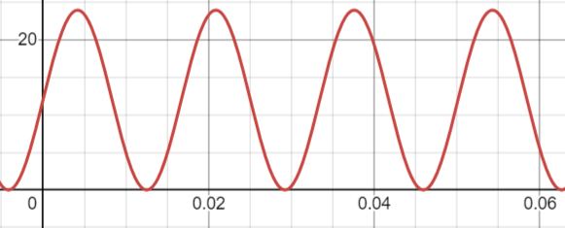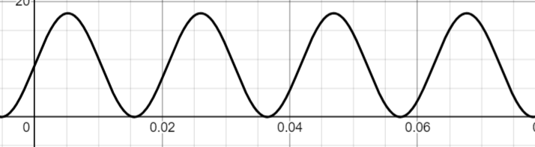

Comparison of The Two Waves
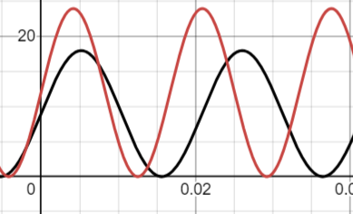
Let's do an analysis of how I got this wave, and how it can be accurate.

I illustrate this wave using the sine equation, which in general form is sinusoidal$y = A sin (B(x-C)) + D$. In this equation, the amplitude is A (to represent a voltage or anti-electromagnetic field, these two are interconnected), the period is 2π (B) (the length of 1 cycle, or in the context of a DC motor is the length of 1 360 degree rotation), the phase shift is is C, and the vertical shift is D. Because we want to calculate the electric current wave, C, namely the phase shift, is replaced with frequency because what we want to know is how fast the wave is oscillating.
The equation becomes like this Y=A sin(2πft)+D. If you notice, there is one function that has been added, namely t, in the equation in the desmos, t is changed to x, because the function of this variable is to show time (or the horizontal position on the line in the desmos).

Creating the Electric Wave Equation for a DC Motor
The modified equation is as follows Y=A sin(2πft)+D. Let's look deeper
how these waves work.
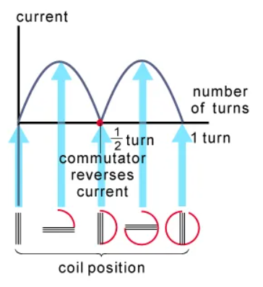
In this picture, the starting point of the current starts to rise, as the current rises the magnetic field also gets stronger. However, before the current is reversed by the commutator, this electric current is weakened by many factors such as mechanical loads and back EMF, before the current is reversed by the commutator. It can also be seen that 2 wave periods = 1, 360 degree rotation. This is why the equation Y=A sin(2πft)+D, uses 2π.

Finding Frequency (f) & Amplitude Values ​​in a 12v DC Motor.
Finding this amplitude is easy because essentially the amplitude is the height from 0 to the maximum value, where the maximum voltage value is 12v. Which means amplitude = 12v. To find the frequency on this DC motor model, we must first know what RPM (rounds per minute) it is. and how many seconds it takes the motor to complete 1 rotation. Let's assume a typical small motor has a speed constant of about 300 RPM/V, then at a voltage of 12 V.
The way to get the frequency is f=RPM60 seconds=3600 RPM60 seconds=60Hz. This is still a rough estimate and actual results may be different.

Finding Frequency (f) & Amplitude Values ​​in a 9v DC Motor.
Just like before, the amplitude value is easy to find, namely 9. And to find the frequency we have to know the RPM of this motor which is powered by 9v. By calculating the voltage ratio. The voltage ratio between 9V and 12V is $\frac{9}{12}$​ or 0.75. This means the voltage of 9V is 75% of 12V.
So, the speed at 9V is: $3600 RPM x 0,75 =2700 RPM$. Now let's calculate the frequency$f=\frac{2700 RPM}{60 detik}=45 Hz$.

Create equations & Results
We have got variables from 9v and 12v DC motors. Now let's create an equation.
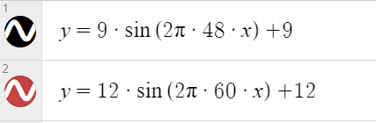
This is the final equation obtained. where the amplitudes are 9 and 12, the frequency values ​​are 48 and 60. The black line is a DC motor wave powered by 9v, while the red is 12v.

From the waves you can see the voltage which affects the speed of rotation. So in the waves you can see that 1 rotation of a DC motor powered by 12v is completed more quickly than a 9v one. This can be seen from the distance between wave ridges, or their period. Where the red wave is narrower than the black wave, which means 1 rotation of 12v is faster than 9v. This proves that the electric current wave and the DC motor rotation output influence each other

Theoretical analysis
:)

Bab 5

Conclusion
Motor DC mentransfer dan merubah energi yang awalnya listrik, menjadi energi magnetik, karena adanya energi magnetik, ini menyebabkan energi kinetik, serta menyebabkan energi termal dan juga energi suara sebagai energi buangan, karena motor DC ini tidak 100% efektif merubah energi.

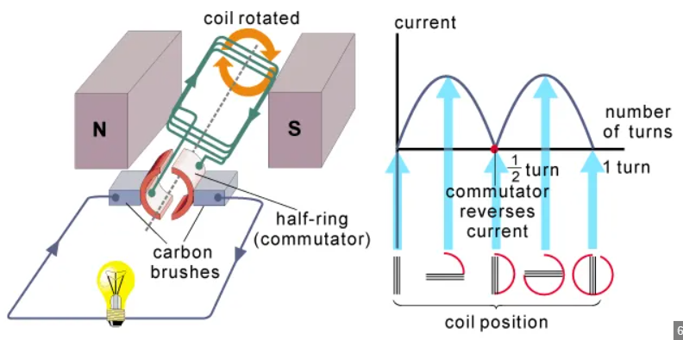
Energy transfer in a DC motor can be visualized through current waves. As the coil rotates in a magnetic field, the commutator reverses the current every half rotation. The current graph shows rising and falling waves which indicate a change in current direction, so the coil continues to rotate. This process converts electrical energy into mechanical energy, which keeps the motor functioning. This current reversal is important to produce continuous rotational movement in the motor. Electric current waves are formed during the transfer of energy in a DC motor. This wave appears because the current direction changes every half rotation.
The electric current wave in a DC motor can be drawn as a sinusoidal graph, which shows the rise and fall of current when the coil rotates and the current is reversed by the commutator.
Factors that influence waves include the speed of rotation of the coil, the strength of the magnetic field, and the electric current flowing in the coil. The faster the rotation and stronger the magnetic field, the larger the current wave that is formed. The efficiency of a DC motor is influenced by the quality of components such as carbon brushes, commutator, and friction. The better the component, the less energy is lost in the form of heat or friction.
The number of turns in the coil affects the energy produced. The more coils there are, the greater the torque produced because the coils capture more of the magnetic field.
The current in a 12V motor is greater than 9V, so the current wave is also higher. This means more energy is transferred in the 12V motor. More energy transferred means the faster the DC motor rotates

Future suggestions
In this experiment there are several concerns. Especially when making coils. When you first make a coil, the end of the coil that will be used for the commutator still has an enamel layer so that the magnetic field from the coil does not work. However, because at that time I still didn't realize it, I tinkered with the initial coil so it was damaged and couldn't be used. Only then did I think about it again, and look for a way to remove the enamel layer.
To be honest, this experiment was my own idea which was inspired by several projects, so the information when making it was very minimal. This experiment made me realize that thorough research is also necessary, even though I said minimal information, this might be because my keywords weren't quite right, and the project references only came from YouTube sources. In the future, project references should not only come from YouTube sources, because out there such as the web or literature may have more complete information.

APPENDIX

Reference
https://study.com/academy/lesson/finding-the-sinusoidal-function.html#:~:text=The%20general%20form%20of%20the,the%20vertical%20shift%20is%20D.

https://kinmore.com/articles/electromagnetic-field-in-a-dc-motor/

https://www.schoolphysics.co.uk/age16-19/Electricity%20and%20magnetism/Electromagnetic%20induction/text/Generator_dc/index.html

https://www.nidec.com/en/technology/motor/glossary/item/back-emf/#:~:text=The%20back%20(or%20counter)%20electromotive,as%20E%20%3D%20KEω.

https://www.vedantu.com/question-answer/state-energy-transformation-in-ac-generator-and-class-12-physics-cbse-60d8461a4fd8652fb1c36b47

https://www.magneticinnovations.com/faq/dc-motor-how-it-works/#:~:text=A%20Direct%20Current%20(DC)%20motor,and%20the%20quality%20was%20low.

