SUMMARY

The Mitra Creation team was formed on January 16, 2023. The team consists of 8 grade 7 students from MTs Technonatura, Depok, Indonesia. Our goal is to create a sophisticated Smart Incubator for the community, specifically to make it easier to plant and research in vitro plants using a new advanced technology. To achieve our goal, we need to attract attention and innovate new ideas, build a productive team, work together, and design a smart incubator according to the market needs.

Orchid is a plant that belongs to the Orchidaceae tribe which is a group of flowering plants that use other plants as their hosts. Orchids can also live in pots, incubators, or glass containers with a planting medium. In contrast to planting orchids in pots, planting in closed glass containers can be called tissue culture. One important stage in tissue culture is the acclimatization stage. To carry out acclimatization, it requires special treatment and a glass container that can properly support plant breeding.

Therefore, we are trying to create a sophisticated tissue culture incubator that has systems that can water automatically, maintain the optimum temperature, then measure and display data related to air temperature and humidity, nitrogen, phosphorus, and potassium content of the planting media, planting media moisture, light intensity, carbon dioxide concentration, and oxygen concentration. That way, the acclimatization process will run more easily and we ourselves can also monitor the situation via cell phone.

To get started, we looked at the planting needs of the acclimatization stage and gathered ideas to meet those needs. We then decide on a solution, write a function list, as well as design requirements. We made 2D sketches of our design ideas, then converted the best design sketch into a 3D model. After that, by making the wiring design and a mechanism animation, we assembled the components and wiring. We also developed programs for each system. We tested every device and fixed any errors that were found. After making sure every device is working properly and placing them in the incubator, we showed our final product to the public.
TABLE OF CONTENT

- ABOUT TEAM ..…………….……………………………………………… 4
1.1 TEAM MEMBERS ....……………………………………………. 6

- ABOUT OUR PROJECT ..…………………....…………………………... 10
2.1 BACKGROUND ……………………………………………….... 10
2.2 MARKET NEEDS ……..………………………………………... 11
2.3 PRODUCT DEFINITION ………...……………………………... 11
2.3.1 FUNCTION LIST ………..……………………………... 11
2.3.2 DESIGN REQUIREMENTS .....………………………... 13
2.4 TECHNOLOGY APPROPRIATE ...……...……………………... 14

- BUSINESS PLAN ...………………………………………………………... 16
3.1 PERSONA ...……………………………………………………... 16
3.2 BOM (BILLS OF MATERIALS) ………………………………... 17
3.3 PRICE ……………………………………………..……………... 22

- ENGINEERING SECTION ……………………………………...………... 23
4.1 TEAM PROCESS ………………………………………………... 23
4.2 DESIGN IDEAS DEVELOPMENT AND SELECTION …...…... 25
4.3 BUILDING PROTOTYPE ………..……………………………... 27
4.3.1 WIRING ………………………………………………... 28
4.3.2 PROGRAMMING ……………………………………… 28
4.4 PERFORMANCE TESTS AND REFINEMENTS …………..….. 34
4.5 FINAL DESIGN ……………………..…………………………... 37

- ARTWORK DESIGNS ………………………...…………………………... 38
1
5

ABOUT TEAM
1

Mitra Creation is a small team formed on January 16, 2023. The team consists of 8 grade 7 students from MTs Technonatura, Depok, Indonesia. Our team name consists of the word 'Mitra' which means partner or co-worker, and 'Creation'. Thus, we define cooperation in creating and innovating as the meaning of our company name.

With various skills such as designing, programming, building, and others, our team tries to design a smart plant incubator to make in vitro orchid planting easier, especially for the acclimatization phase. We want to introduce smart plant incubator technology to people in Indonesia, so that those who are still using the old way of growing orchids can switch to an easier and more practical way.

VISION :
- To create a sophisticated Smart Incubator for the community, specifically to make it easier for those who want to plant and research in vitro plants using a new advanced technology.

MISSION :
- Attract attention and innovate new ideas for the public to switch from old ways or ideas of in vitro planting
- Build a team that excels in various fields, also creative and productive
- Innovate and work well together in the manufacture of the Smart Incubator
- Design a Smart Incubator that is quality, but also inexpensive and easy to use

Each member works in a different field. Everything is tailored to the passion and abilities of each. Each team member works in a different division as well. There are 3 divisions namely engineering division, business division, and media division. The following are the divisions and the roles within them:

- Team leader: The team leader manage his team members

- Engineering
  - Building Team: The building / mechanic team builds, assembles, tests, and repairs the devices.
  - 3D Design Team: The 3D team creates a 3D design concept from the 2D sketch.
  - Software/Programming Team: The software or the programming team develop programs for the IOT system.

- Media
  - Designer Team: The designer team designs the team's publication such as logos, covers, and others.
  - Documentation Team: The documentation team is documenting team activities.

- Business
  - Financial Managers: The financial managers organize team finance.

1.2 TEAM MEMBERS

IBADURRAHMAN LABIB ULYA

Leader, Programmer, & 3D Designer
As a leader, Labib manages the team and ensures that the team works well. He works hard on the project to bring out the best. With his expertise in programming and 3D design, he also works as a programmer who will develop programs for the systems of devices for the incubator, and create 3D designs with Asti.

SHABRINA AZIZAH LA ANGKA

Manager & 2D Designer
Shabrina assists Labib in managing the team as a manager. Besides that, Shabrina also works in the media division. Due to her interest that brought her into the world of art, Shabrina served as a 2D designer who designs the team's needs.

PINASTI AWLIYA FIRMANSYAH

Business & 3D Designer
With her main role in the business division, Asti is responsible for all business matters of the team. Her ability to plan and organize led her to this important role. She manages team finances, makes proposals, and more. Apart from that, Asti also took part in 3D design. She designs the incubator concept from a 2D sketch to a 3D model.

SYAMIL ATQIYA YUSUF
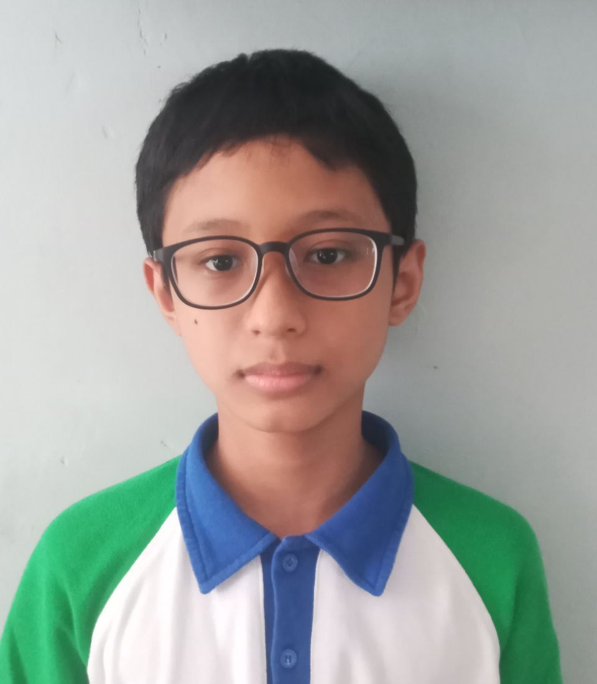
Business
Syamil works in the business division. He helps Asti in financial matters.

GHAZI ABYAN BAIHAQI

Programmer
Ghazi was chosen to be a programmer because of his experience in the field of programming. He is in charge of programming the IOT systems with Labib.

MUHAMMAD YASIR AKBAR
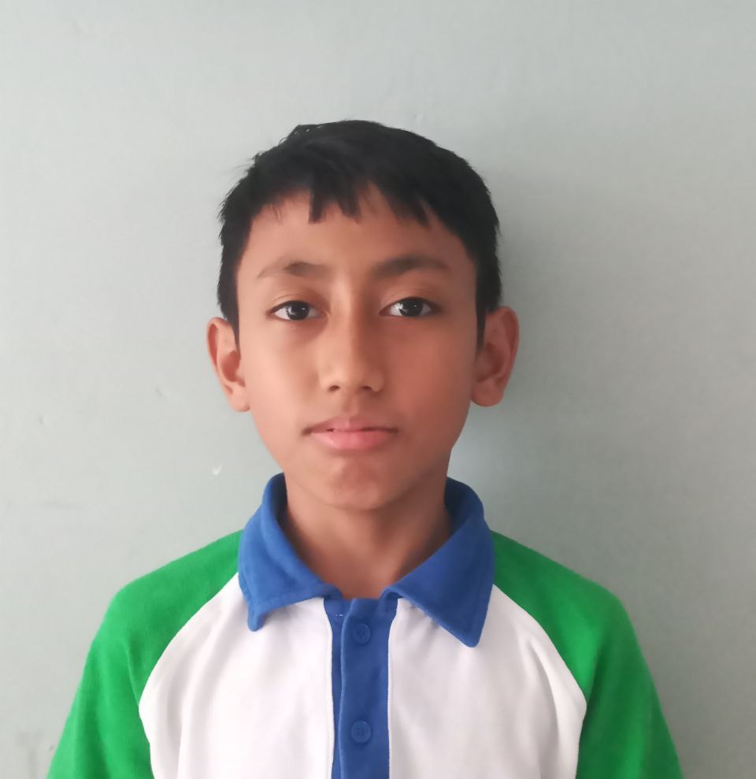
Mechanic
Akbar volunteered as a mechanic because of his interest in building and designing. He helps the team find the incubator concept, then assemble its components and wiring with other mechanics.

ASHABUL KAHFI

Mechanic
Ibal's prowess in mechanics makes him a mechanic. By confirming with Labib, Ibal designs and builds the wiring for the incubator system. Realizing that success is difficult to achieve, he works hard with all his might to create the best smart plant incubator.

AZZAM KHAIRULLAH ADIANTO

Documentation & Mechanic
Azzam helps in the media division, especially for documentation. He takes documentation as the project is being worked on. While in charge of taking documentation, Azzam also helps by finding the incubator design and assembling the components as a mechanic.

1
5

ABOUT OUR PROJECT
2

2.1 BACKGROUND

Orchid is a plant that belongs to the Orchidaceae tribe. Orchidaceae is a group of flowering plants that use other plants as their hosts. Apart from growing attached to other plants, orchids can also live in pots, incubators, or glass containers with planting media which are usually made of coconut coir, broken bricks, and charcoal. In contrast to planting orchids in pots, planting in closed glass containers can be called tissue culture, which is a way to breed/grow orchids in vitro which means 'in glass'.

One very important stage in tissue culture is the acclimatization stage. Acclimatization is an effort to adjust and adapt a particular organism to the new environment it will enter (Ferdian, 2022). Gradual special treatment is required to carry out acclimatization because acclimatization is one of the important factors that determine the success of tissue culture. Tissue culture also requires glass containers that can properly support plant breeding/planting. Therefore, we are trying to create a sophisticated tissue culture incubator that has a mechanism that can water automatically, maintain the optimum temperature, then measure and display data related to air temperature and humidity, nitrogen, phosphorus and potassium content of the planting media, planting media moisture, light intensity, carbon dioxide concentration, and oxygen concentration. That way, the acclimatization process will run more easily and we ourselves can also monitor the situation via cell phone.
2.2 MARKET NEEDS

Orchids are very sensitive to environmental changes, sunlight, and water. Those things need to be considered in detail. Orchids should not be excess or lack sunlight, as well as water. For watering, the schedule depends on the type of orchid, but generally orchids are watered once a week to avoid drying out and to keep the planting media moist.

Watering that is done manually by ourselves is sometimes irregular which can be caused by our busyness or even forgetting. Regulating the temperature and humidity of the environment around plants that are planted in the open is also difficult for us to do. Therefore, we designed a closed Smart Incubator that has IOT systems. It’s designed to be able to water automatically, maintain the temperature, and maintain the humidity that the plants need.

2.3 PRODUCT DEFINITION

Here, we are trying to create a Smart Incubator product for plants which we named PINC (Plant Incubator). In our product, we provide sophisticated features and functions that are expected to facilitate the cultivation of in vitro plants, especially for the tissue culture acclimatization phase.

2.3.1 FUNCTION LIST

- Able to water automatically
Automatic sprinklers will certainly make it easier to water the plants. It can also help in keeping the plant humid.

- Able to maintain temperature
We use LED lights for increasing the temperature and a fan for lowering the temperature. These two devices will help in maintaining the optimum temperature.

- Able to provide temperature data
Data related to the air temperature in the incubator will be measured using DHT11 and can be sent to LCD and a mobile app.

- Able to provide moisture data
Data related to the planting media moisture in the incubator will be measured using a Hygrometer and can be sent to LCD and a mobile app.

- Able to provide light intensity data
Data related to the light intensity in the incubator will be measured using LDR and can be sent to LCD and a mobile app.

- Able to provide oxygen data
Data related to the oxygen concentration in the incubator will be measured using an O2 sensor and can be sent to LCD and a mobile app.

- Able to provide CO2 data
Data related to the carbon dioxide concentration in the incubator will be measured using a CO2 sensor and can be sent to LCD and a mobile app.

- Able to provide NPK data
Data related to the NPK’s amount of the planting media in the incubator will be measured using an NPK sensor and can be sent to LCD and a mobile app.

- Able to provide date and time data
Data related to time and date (second, minute, hour, day, month, & year) will be tracked using RTC and can be sent to LCD and a mobile app.

- Able to take pictures with a camera
The camera placed in the upper corner of the incubator takes pictures of the plant's condition and sends them to a mobile app.
2.3.2 DESIGN REQUIREMENTS

- Automatic watering
- Hose
- T hose connector
- Nozzle sprinkler
- Drat
- Pipe
- Solenoid

- Maintain temperature
- Strip LED lights
- Fan DC 12V 9X9

- Temperature sensor
- DHT 11

- Humidity sensor
- Hygrometer

- Light intensity sensor
- LDR light sensor

- Picture taking
- OV7679 camera

- Oxygen sensor
- O2 sensor (0-25% vol, 12C)

- Carbon dioxide sensor
- Infrared CO2 sensor

- NPK sensor
- RS485 soil NPK sensor

- Date and time tracking
- RTC DS3231

- Tool box
- ESP8266
- Breadboard
- Male to female jumper cable
- Male to male jumper cable
- Female to female jumper cable
- Relay
- Adaptor
- Acrylic

2.4 TECHNOLOGY APPROPRIATE

In our incubator product or what we call PINC (Plant Incubator), we provide ESP8266 for IOT (Internet Of Things) systems. The term IoT refers to the collective network of connected devices and technologies that facilitate communication between devices and the cloud, as well as between devices themselves. Thanks to the advent of cheap computer chips and high-bandwidth telecommunications. IoT is actually a term that describes a collection of devices consisting of sensors, software and other technologies with the aim of exchanging data with other devices and systems via the internet.

In the context of IoT it can be any device with any internal sensor that has the ability to collect and transfer data over a network without manual intervention. Technologies embedded in objects help IoT devices to interact with the internal state and external environment, which in turn helps in the decision-making process. IoT is a concept that connects all devices to the internet and allows IoT devices to communicate with each other via the internet.

Basically, it is known that IoT is an internet network that functions to share data with other devices, with the concept of connecting all devices to the internet and allowing IoT devices to communicate with each other via the internet, actually there is another term regarding IoT that describes a collection of IoT devices which consists of sensor devices, software, and other technologies that aim to exchange data with other devices and systems via the internet.

Our product will have an ESP box which is used as the main system of the Smart Incubator. Inside the ESP Box, there are various tools to make our product happen. The tool is like a Breadboard which is useful for adding jumper cable ports. There is also a relay in the ESP Box which is useful for stabilizing the volt current. Our Smart Incubator has several advanced functions that are expected to help in closed indoor planting, namely measuring temperature, light intensity, humidity, adjusting temperature, and more. We use a DHT11 to measure temperature, a hygrometer for planting media moisture, and an LDR light meter to measure light intensity. Our team also added several features in the incubator to be able to maintain temperature and humidity using LED strips and fans, and also water automatically. Automatic sprinklers consist of a hose, T-hose, sprinkler nozzle, and a solenoid to open and close the water channel.

1
5

BUSINESS PLAN
3

3.1 PERSONA

The target market for our incubator product is people who are interested and want to plant orchids or research them using closed incubators instead of using pots in the open. We target people with a lower middle class economy to help those who want to open a business, especially businesses in tissue culture acclimatization because tissue culture acclimatization businesses are still relatively small, but have great opportunities.

Apart from helping those who want to start a business, we also want to help people who want to research plants. Even so, our products are not only for researchers or people who want to have a business, but also people who love growing plants, so that planting becomes easier and more enjoyable.

Examples of our target market are; Horticulturist, Gardener, Businessman, etc.
3.2 BOM (BILLS OF MATERIALS)

No. | Tool | QYT | Price | Sub total | Shipping | Total | Link | Description | Update
1. | Hygrometer | 1 | Rp. 6.200 | Rp. 6.200 | Rp. 5.750 | Rp. 11.950 | https://www.tokopedia.com/permony/soil-moisture-hygrometer-sensor-kelembaban-tanah-module-lm393 | Useful tool for measuring medium moisture. This tool will be planted in the ground and will then send data to the cellphone | Available at school
2. | DHT11 | 1 | Rp. 17.500 | Rp. 17.500 | Rp. 5.750 | Rp. 23.250 | https://www.tokopedia.com/permony/dht11-digital-temperature-and-humidity-sensor-for-arduino-dht-11?extParam=ivf%3Dfalse%26src%3Dsearch | This small tool will be hung above the incubator as a temperature gauge | Available at school
3. | Solenoid | 1 | Rp. 38.800 | Rp. 38.800 | Rp. 7.000 | Rp. 45.800 | https://www.tokopedia.com/glodok123/electric-water-selenoid-valve-control-switch-air-1-2-3-4-dc-12v-nc-no-dc12v-lurus-a6-tanpa-bubble?extParam=ivf%3Dfalse%26src%3Dsearch | Solenoid works to close the end of the pipe when water does not come out of the pipe when it is turned on | Available at school
4. | LED strip light 12 volt DC | 3 (1m) | Rp. 4.700 | Rp  14.100 | Rp. 11.500 | Rp. 25.600 | https://www.tokopedia.com/grand003/lampu-selang-led-strip-5050-1-meter-tidak-free-soket-led-drop-ceilin-kuning-ww?extParam=ivf%3Dtrue&src=topads | The LED light attached to the top of the incubator (inside) and is useful for lighting and warmth | Available at school
5. | LCD 16x2 | 1 | Rp. 44.900 | Rp. 44.900 | Rp. 20.000 | Rp. 64.900 | https://shopee.co.id/product/21754764/6677040216?gclid=Cj0KCQiAq5meBhCyARIsAJrtdr6x9Gk-j16rIo9_XO-bBfkVmrenpvZNJKOu9QxUOvTlEMTCYRhlGEMaAgeZEALw_wcB | The LCD displays temperature, humidity and light intensity | Available at school
6. | Male to female jumper cable | 30 | Rp. 719 | Rp. 21.570 | Rp. 2.330 | Rp. 23.900 | https://www.tokopedia.com/kivala/kabel-jumper-dupont-male-female-30cm-breadboard-arduino-raspberry?extParam=whid%3D4088995 | Useful cable to connect ESP Box to DHT11, Hygrometer, LDR Light Sensor, etc | Available at school
7. | Male to male jumper cable | 30 | Rp. 719 | Rp. 21.570 | Rp. 2.330 | Rp. 23.900 | https://tokopedia.link/SqbKCZi5Hwb | Useful cable to connect ESP Box to DHT11, Hygrometer, LDR Light Sensor, etc | Available at school
8. | Female to female jumper cable | 30 | Rp. 719 | Rp. 21.570 | Rp. 2.330 | Rp. 23.900 | https://tokopedia.link/ITxAMiU4Hwb | Useful cable to connect DHT11, Hygrometer, etc to ESP Box | Available at school
9. | Fan DC 12v 9x9cm | 1 | Rp. 11.000 | Rp. 11.000 | Rp. 18.000 | Rp. 29.000 | https://shp.ee/6ht6wc2 | This tool helps cool the inside of the incubator so that the temperature doesn't get too hot | Available at school
10. | Relay 12v 3 channel 220 | 1 | Rp. 29.900 | Rp. 29.900 | Rp. 5.750 | Rp. 35.650 | https://www.tokopedia.com/breakneck/relay-12v-optocoupler-4-channel?extParam=ivf%3Dfalse&src=topads | The relay is useful for stabilizing the volt current coming from the adapter | Available at school
11. | Adaptor DC 12V 2A | 2 | Rp. 25.000 | Rp. 12.500 | Rp. 11,500 | Rp. 36.500 | https://www.tokopedia.com/toko-cctv-1/adaptor-2a-12v-reall-best-seller?extParam=ivf%3Dfalse&src=topads | Works in flowing volts and amperes | Available at school
12. | 5 mm Acrylic | 11 | Rp. 1.000 | Rp. 11.000 | Rp. 11.500 | Rp. 22.500 | https://www.tokopedia.com/centralmika/mika-akrilik-potongan-5mm-bening-acrylic-custom-akrilik-lembaran | Useful for making ESP boxes, protecting cameras, etc | Available at school
13. | RTC DS3231 | 1 | Rp. 32.500 | Rp. 32.500 | Rp. 16.000 | Rp. 48.500 | https://www.tokopedia.com/archive-omlemon/rtc-ds3231-seri-sn-real-time-clock-i2c-battery-module-modul-ds3231sn?extParam=ivf%3Dfalse%26src%3Dsearch | Displays the time and date: second, minute, hour, day, month, and year | Available at school
14. | LDR Light sensor | 1 | Rp. 11.000 | Rp. 11.000 | Rp. 11.500 | Rp. 22.500 | https://tokopedia.link/OJ7jD9utGwb | The LDR light sensor is useful for measuring light intensity | Available at school
15. | ESP8266 | 1 | Rp. 36.500 | Rp. 36.500 | Rp. 11.500 | Rp. 48.000 | https://tokopedia.link/40xlilxuGwb | Useful as an IOT main system | Available at school
16. | Hose | 3 | 5.800 | 17.400 | 9.000 | Rp. 26.400 | https://tokopedia.link/WRHqBHBRHwb | Channeling water to the sprinkler nozzle | Available at school
17. | T hose connector | 1 | 2.500 | 2.500 | 11.500 | Rp. 14.000 | https://tokopedia.link/zSfCP3mRHwb | The T hose connector is used to branch a new hose | Available at school
18. | Nozzle Sprinkler | 2 | Rp. 4.100 | Rp. 8.200 | Rp. 11.500 | Rp. 19.700 | https://tokopedia.link/noPffHtyGwb | Used to spray water. It has 4 sides that can emit water | Available at school
19. | Drat | 1 | Rp. 1.800 | Rp. 1.800 | Rp. 11.500 | Rp. 13.300 | https://tokopedia.link/W1s610HyGwb | Is used to connect the solenoid to the hose | Available at school
20. | Breadboard 830 Points | 1 | Rp. 11.500 | Rp. 11.500 | Rp. 5.750 | Rp. 17.250 | https://tokopedia.link/K16mGiS5Hwb | Used to add a jumper cable port | Available at school
21. | 1,5 inch pipe | 1 | 16.000 | 16.000 | 11.500 | Rp. 27.500 | https://tokopedia.link/jw13F4SbIwb | Used to drain water | Available at school
22. | 5 mm Glass | 2 | 150.000 | 300.000 | Rp, 11,500 | Rp. 311.500 | https://tokopedia.link/fe0wKdsdIwb | Used to assemble the incubator | Available at school
23. | Bulkhead Fitting | 3 | Rp. 13.900 | Rp. 41.700 | Rp. 11.500 | Rp. 53.200 | https://www.tokopedia.com/imey177/vault-ring-penguin-34-inch-fitting-tangki-bulkhead-fitting?extParam=ivf%3Dfalse%26src%3Dsearch | Covering the holes in the incubator, also protects against excess raindrops | Available at school
24. | OV7670 camera | 1 | Rp. 55.000 | Rp. 55.000 | Rp. 8.000 | Rp. 63.000 | https://tokopedia.link/dyACdUw2Uzb | To see the condition of the plant. | Available
25. | O2 Sensor (0-25% Vol, I2C) | 1 | Rp.827.800 | Rp.  827.800 | - | Rp. 827.800 | https://www.dfrobot.com/product-2052.html | Able to measure the ambient O2 concentration | Not available at school
26. | RS485 Soil NPK Sensor | 1 | Rp. 890.100 | Rp. 890.100 | - | Rp. 890.100 | https://shopee.co.id/RS485-Soil-NPK-Sensor-nitrogen-phosphorus-Potassium-tester-3-in-1-soil-nutrient-detector-i.32708560.11222530253 | This tool is useful for detecting the content of nitrogen, phosphorus, and potassium in the planting media | Not available at school
27. | Infrared Carbon Dioxide Sensor | 1 | Rp.  1.999.000 | Rp.  1.999.000 | Rp.  15.000 | Rp.  2.014.000 | https://www.dfrobot.com/product-1549.html | To measure carbon dioxide gas concentration | Not available at school
 | Total : Rp. 4.743.202

3.3 PRICE
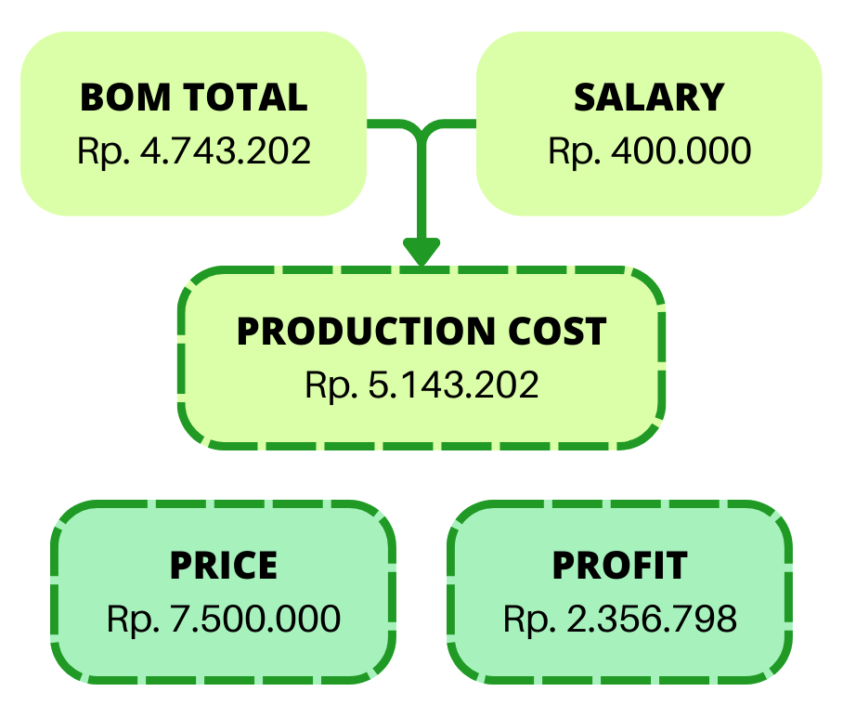

1
5

ENGINEERING SECTION
4

4.1 TEAM PROCESS

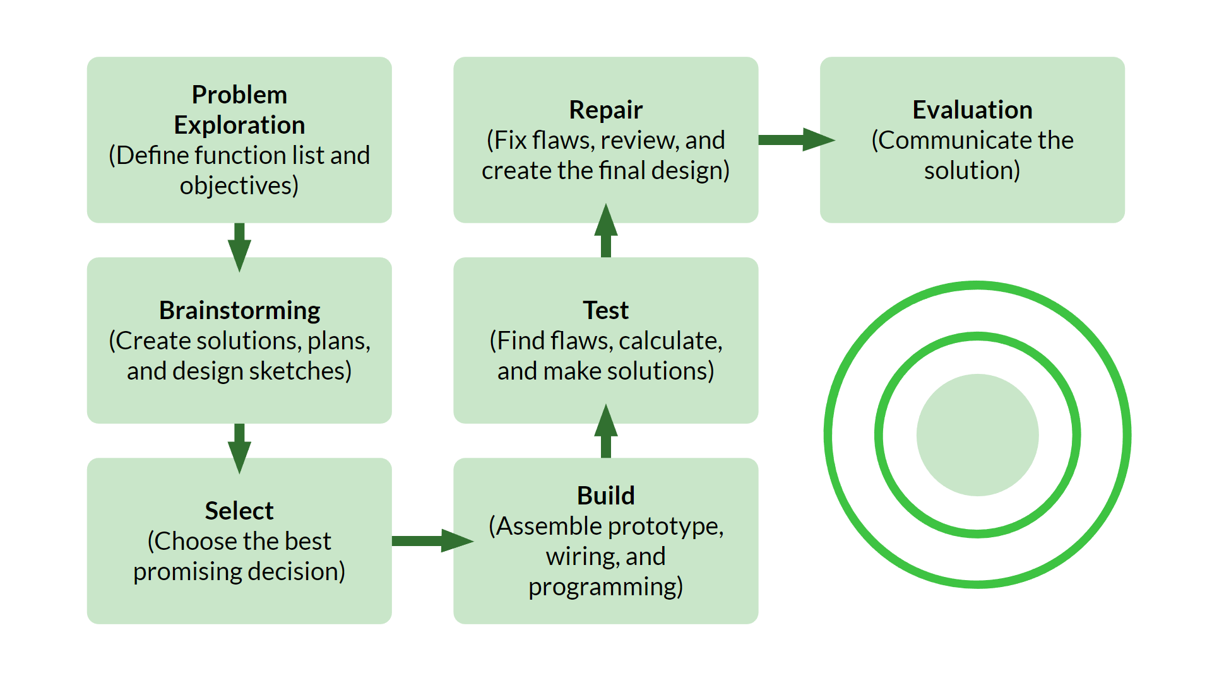

To get started, we looked at the planting needs of the acclimatization stage and gathered ideas to meet those needs. We also look for problems or deficiencies in products sold in the market to create better product ideas. By defining the problem, we make several alternative solutions that are tailored to the needs of the target market, arrange them, and make conclusions regarding the solutions we make. With the conclusion of all the existing solutions, we write the function list, design requirements, incubator specifications, and the purpose of each part in the incubator system.

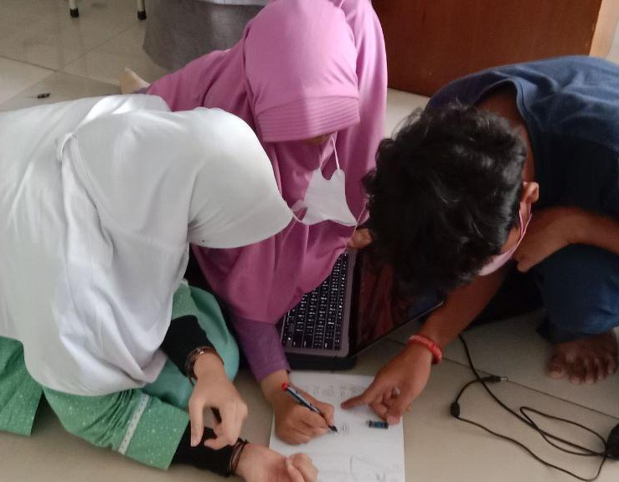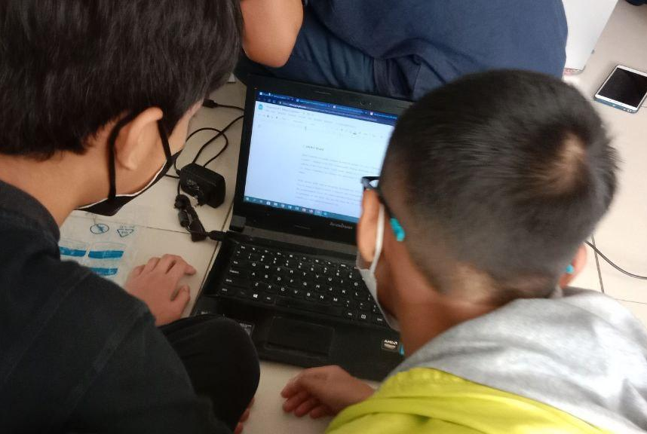

Once the function list and specifications with each goal have been concluded, we continue by discussing and sharing our ideas based on our objective. We draw several sketches of our design ideas on paper to express all the ideas in our heads freely. We made multiple sketches while combining and developing our ideas, then drew them into one selected design sketch that we thought was the best and most promising. From a 2d sketch, we converted it into a 3d model to be able to refine and convey the design with greater clarity and detail using Fusion 360 by Autodesk.

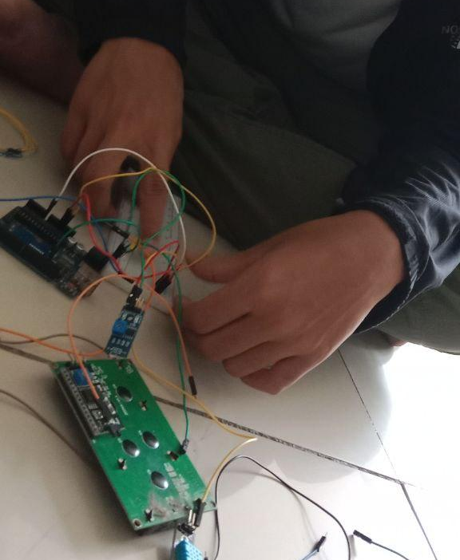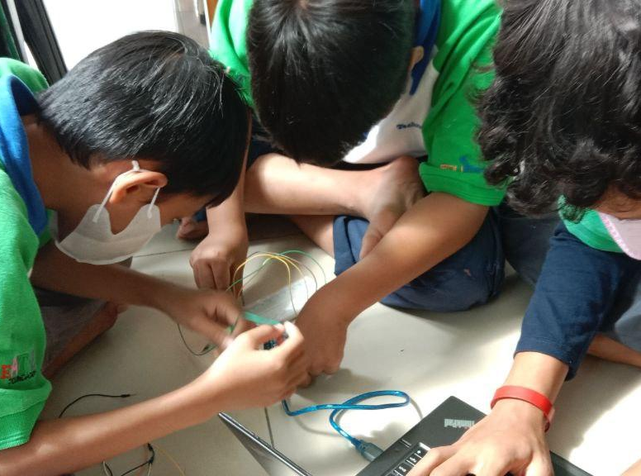

While working on the 3D model, other members, especially mechanics and programmers, started preparing by making a wiring system design with Fritzing. We also created an animation of the mechanism of the devices. This was done to make it easier for programmers to create the systems for the incubator. Afterwards, we assemble the components and wiring, and also develop a program for the systems according to the 3d model we made.

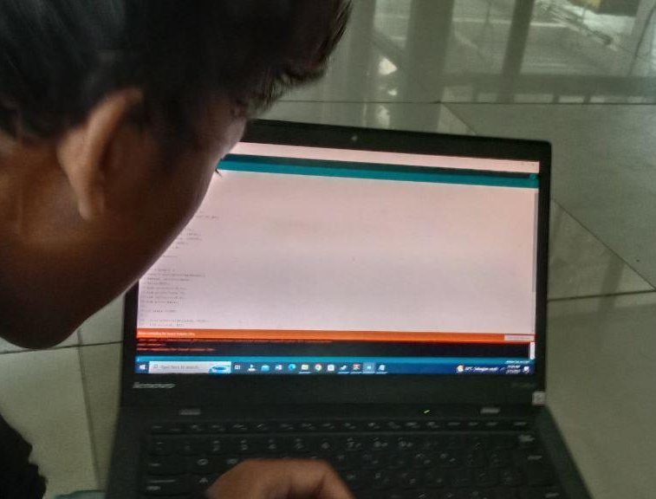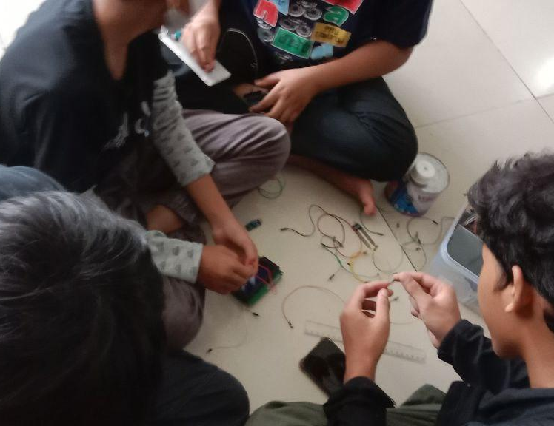

Next up, we test the components and wiring that have been assembled and connected with the program. We evaluate the weaknesses and strengths of our design according to the results of the tests we carried out and create alternative solutions for the flaws we find. After that, we decide on the best alternative solution by considering all the things needed for the final design, then repair it together. The final design is also tested again to see if it works like how we expected it to do.

4.2 DESIGN IDEAS DEVELOPMENT AND SELECTION

- DESIGN 1
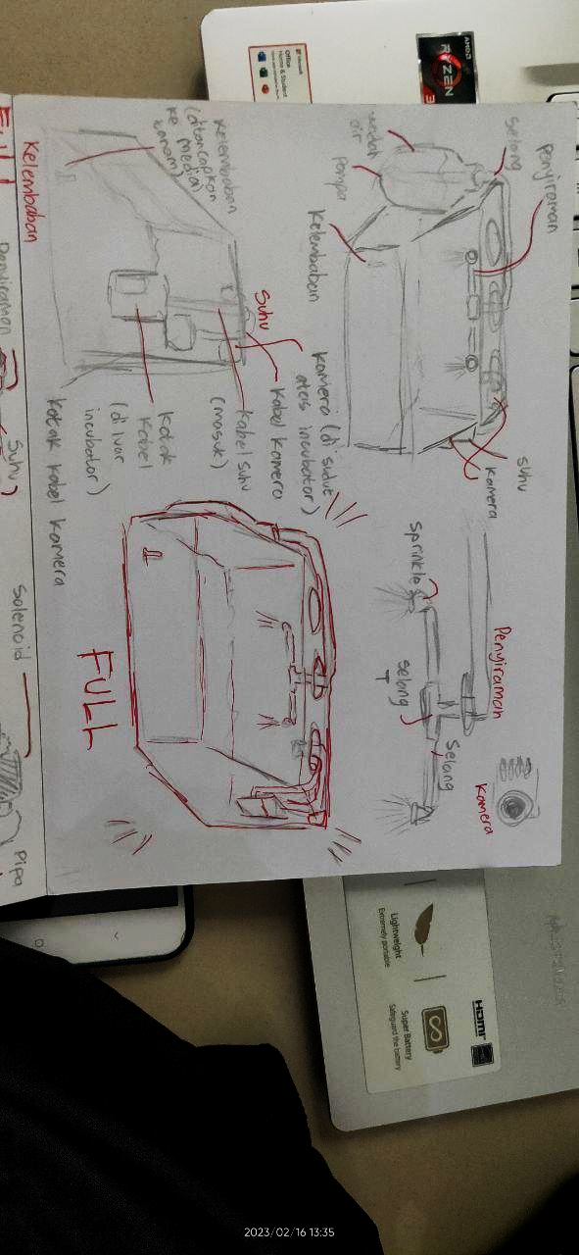
- The watering pipe funnels water from a gallon of water storage through the incubator's center hole
- The tool box is placed on the side of the incubator
- The camera is located in the upper left corner of the incubator
- The cables exit through the incubator's left hole and are connected to the tool box

- DESIGN 2
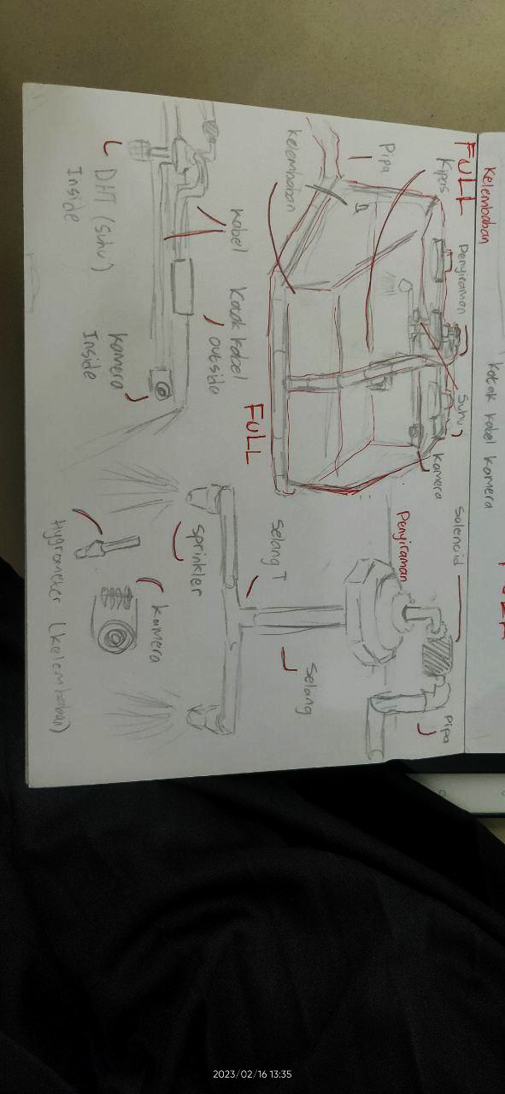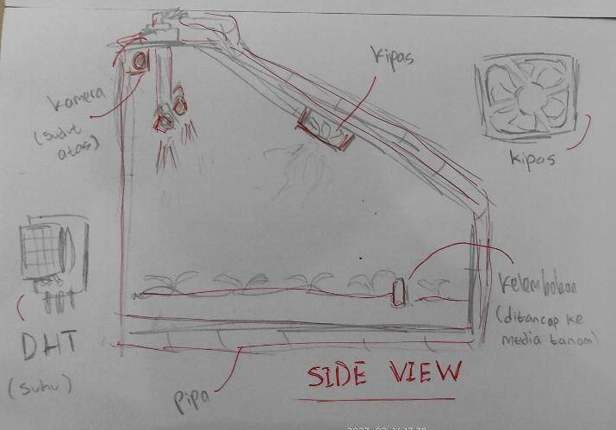
- The watering pipe is connected to the water tank
- The fan is located at the upper front of the incubator
- There are bulkheads on all three incubator holes
- The hygrometer is placed close to the front corner of the incubator
- The tool box is placed on the top edge of the incubator
- The cables exit through the center hole of the incubator and connect to the tool box

- DESIGN 3
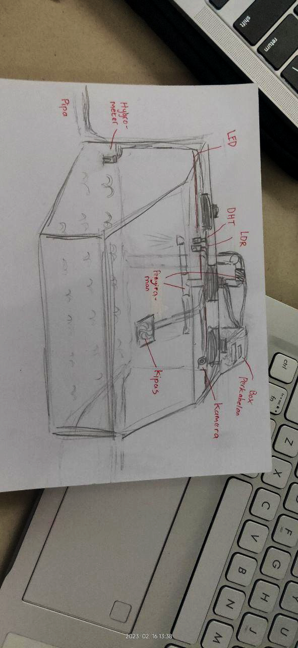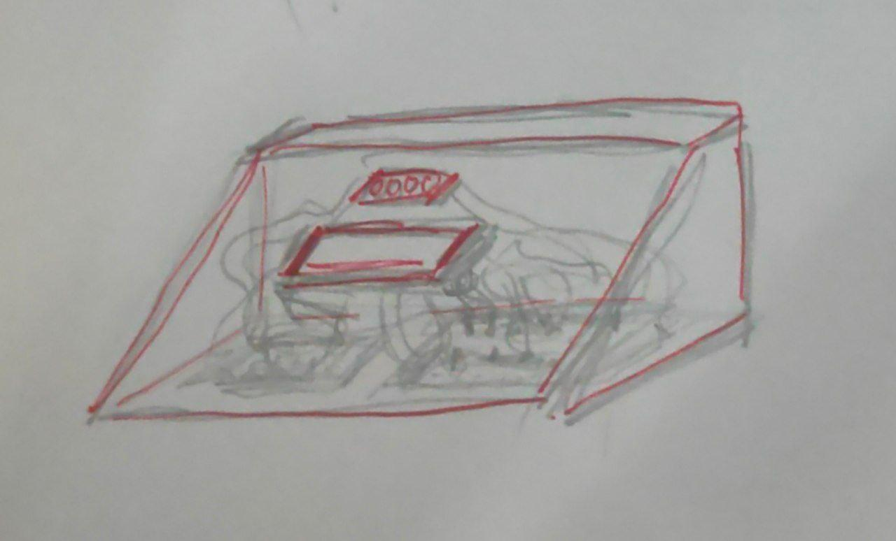
- The watering pipe is in a vertical position
- The hygrometer is placed close to the rear corner of the incubator
- There is an LED light attached to the top side of the glass inside the incubator
- DHT and LDR are affixed to the top side of the incubator's rear glass

- DESIGN 4 (SELECTED DESIGN)
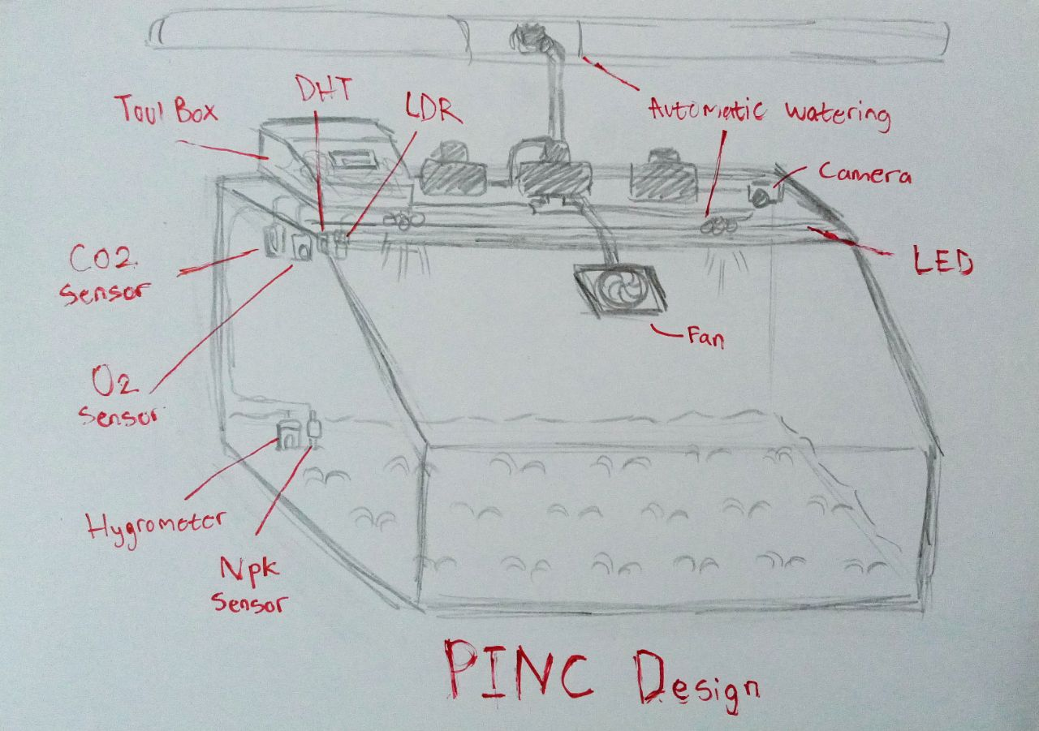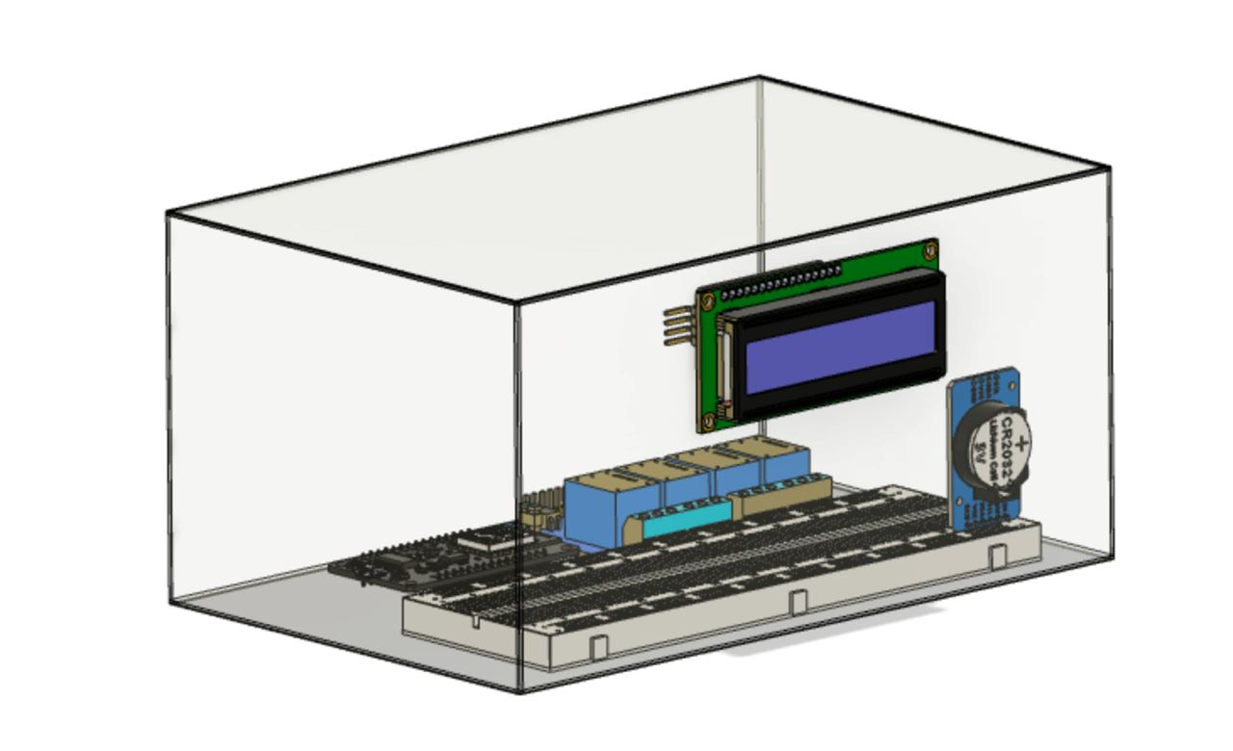
- The watering pipe is in a horizontal position
- The watering hose is attached to the top side in the incubator
- The fan position is higher than before
- There is an NPK sensor that is plugged into the planting medium next to the hygrometer
- There are O2 and CO2 sensors attached to the glass next to DHT and LDR

4.3 BUILDING PROTOTYPE
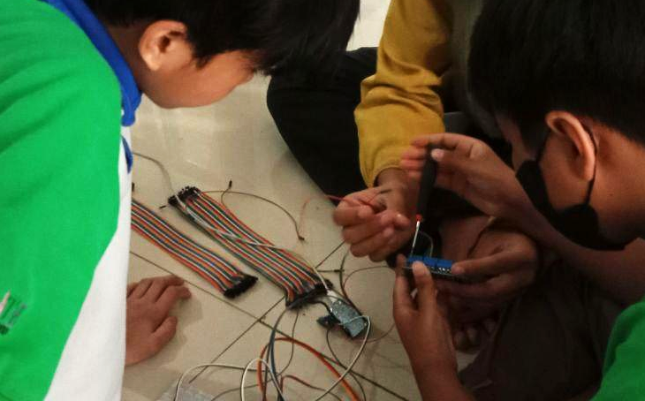 Wiring 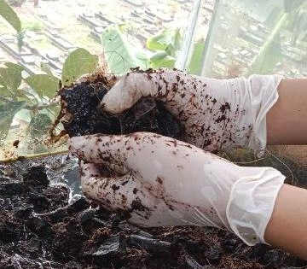 Planting

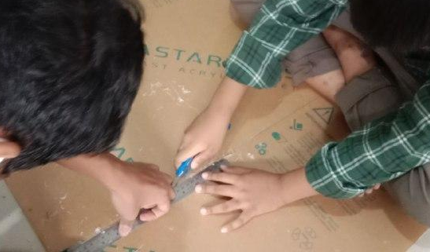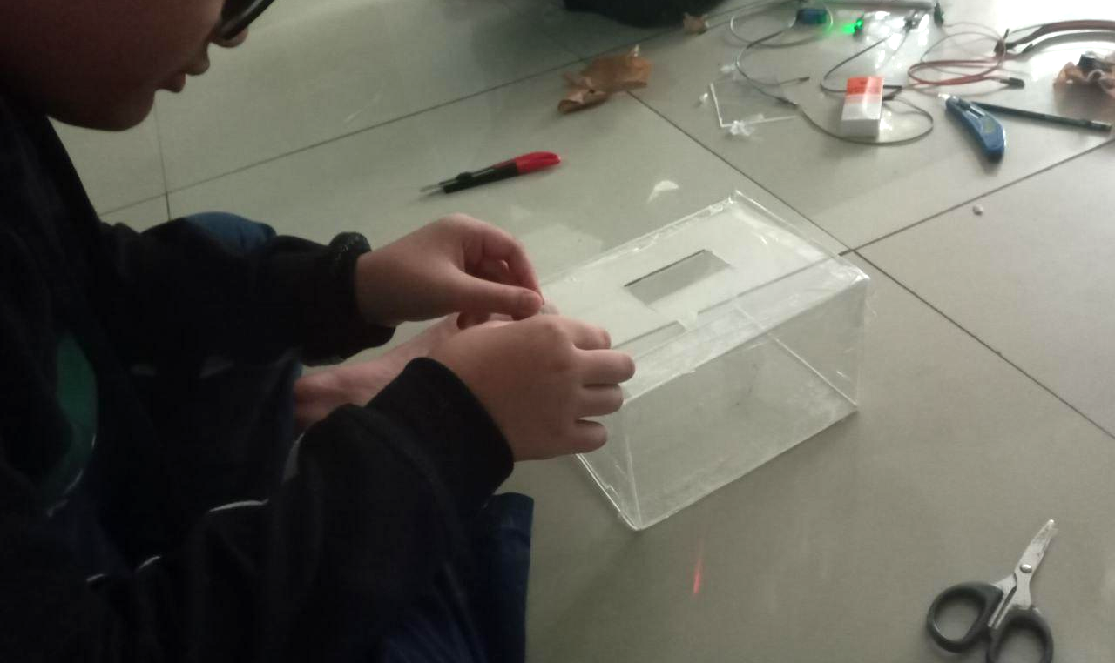
Tool box making

4.3.1 WIRING

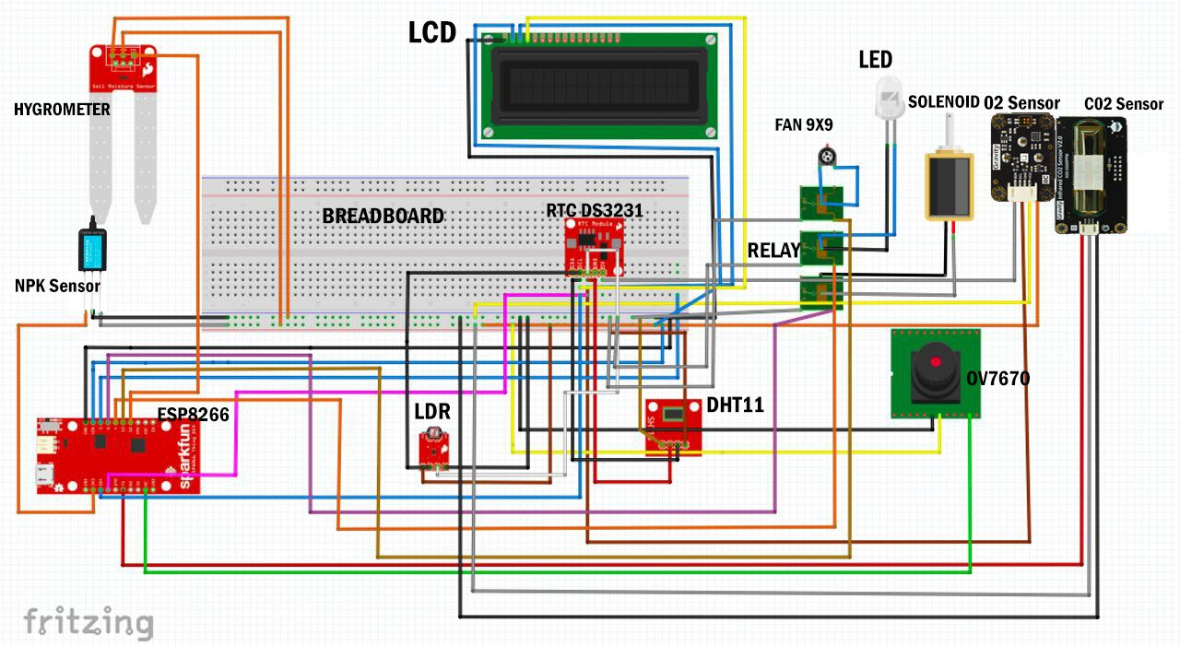

4.3.2 PROGRAMMING

- LIBRARY PROGRAM
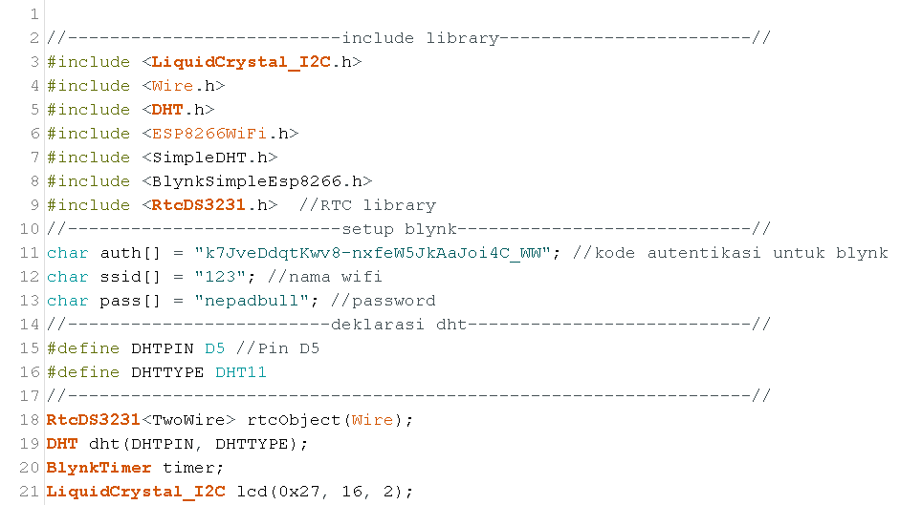

- DHT & SERIAL MONITOR PROGRAM

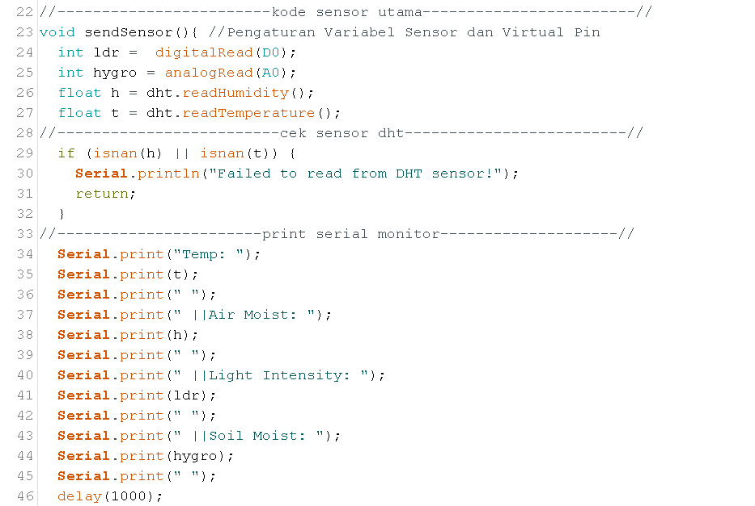
- RELAY AUTOMATION PROGRAM
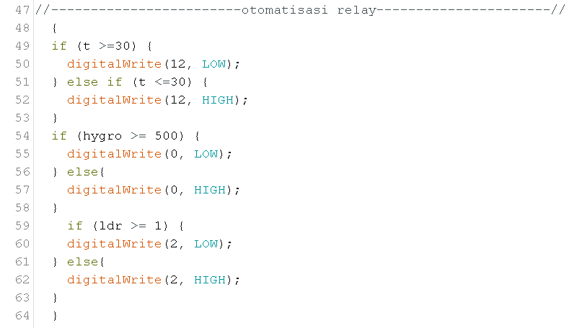

- LCD PROGRAM & VIRTUAL PIN
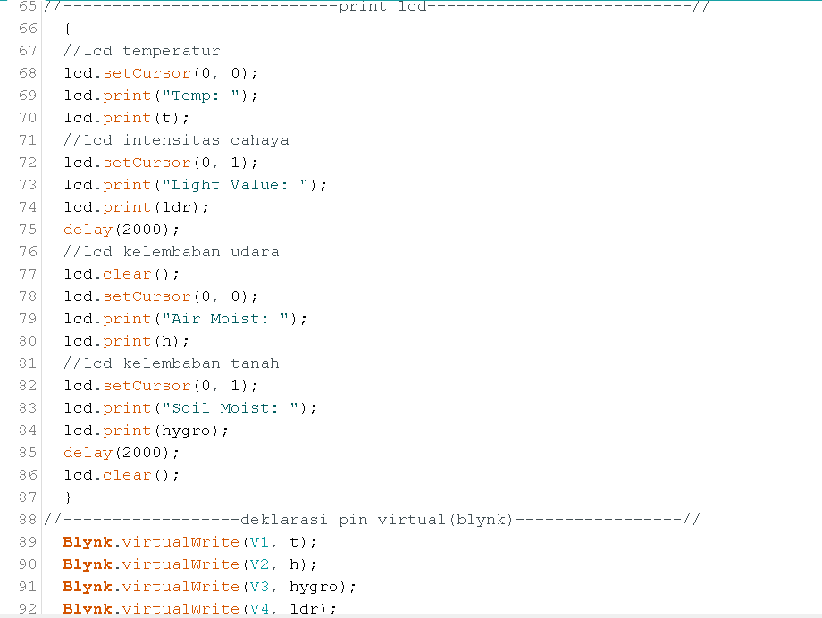
- VOID SETUP PROGRAM
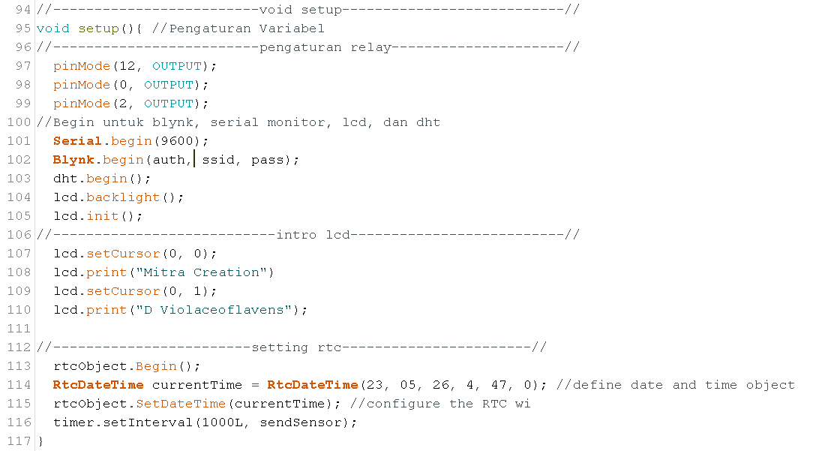
- VOID LOOP PROGRAM
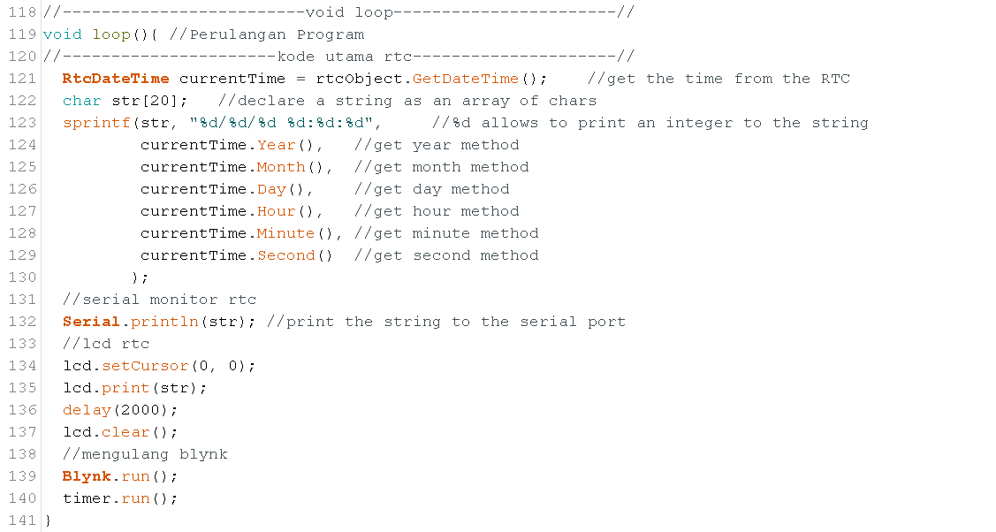
- FINAL PROGRAM
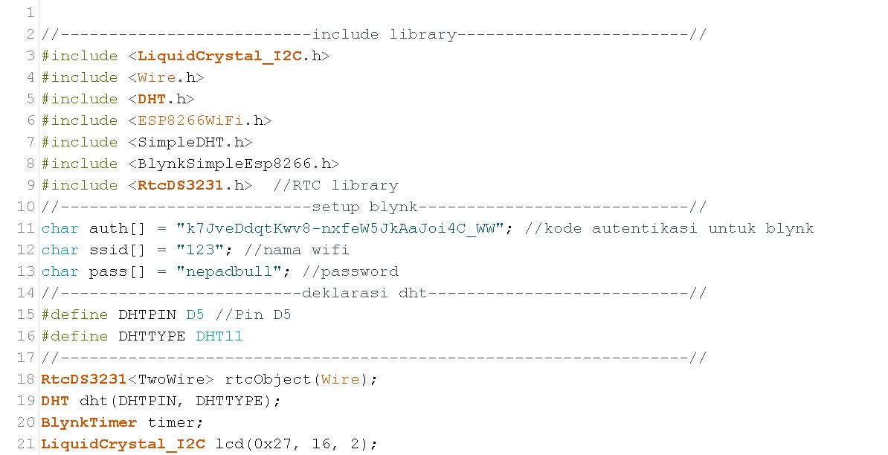
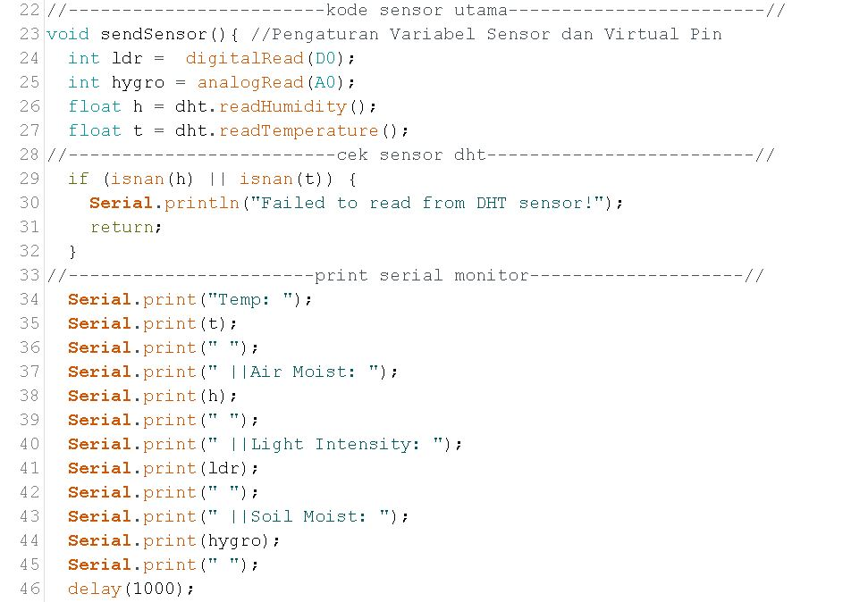
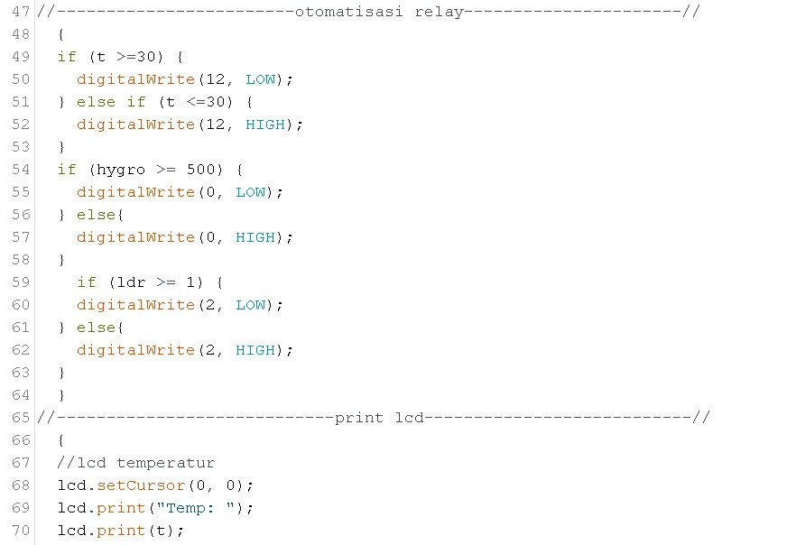
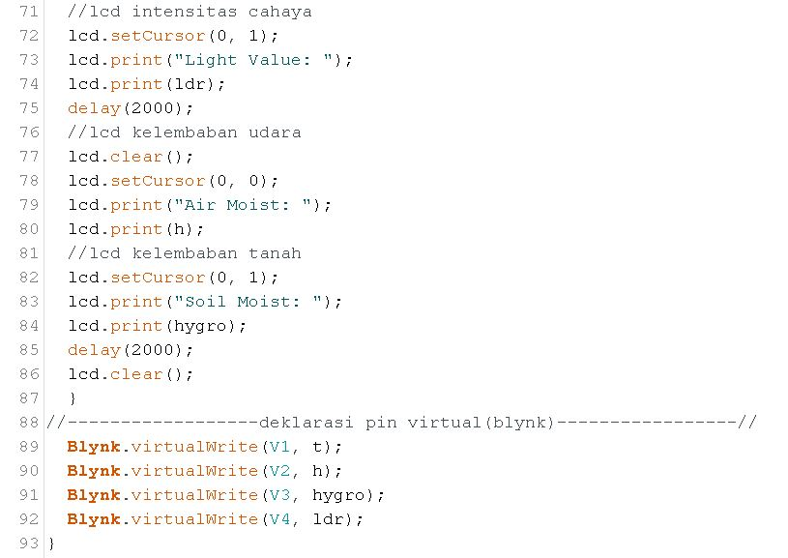
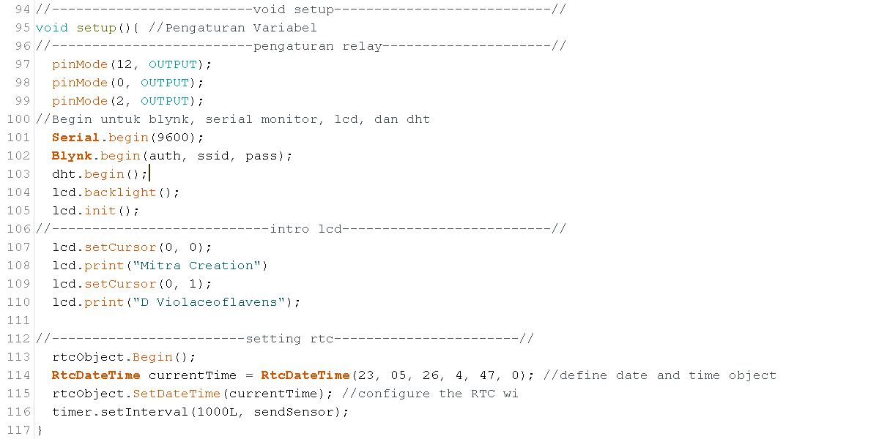
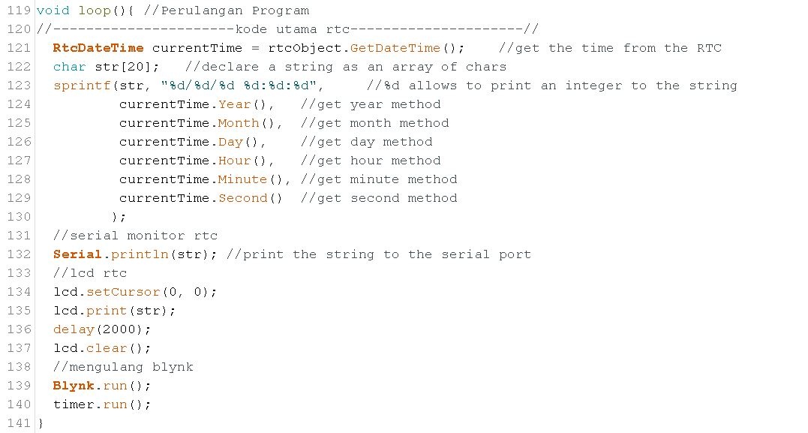

4.4 PERFORMANCE TESTS AND REFINEMENTS
Before coming up with the final design, we test whether the systems are running properly. We have to make sure that all devices can do what they are supposed to do. By testing, we can find errors and then fix them.

- ESP TEST
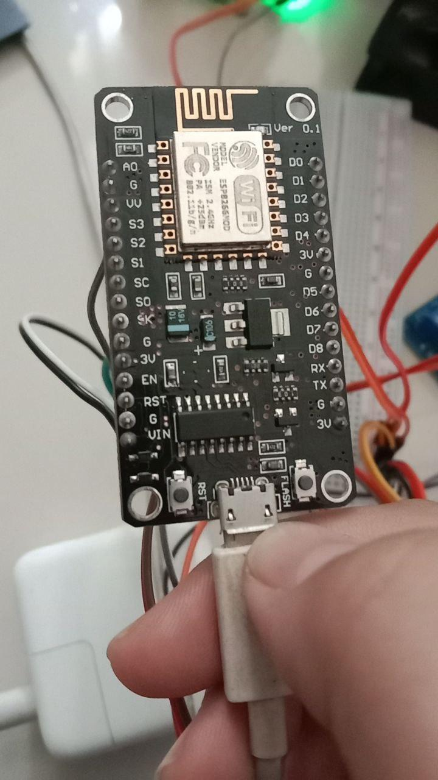
The ESP is capable of receiving measurement data from DHT, LDR, and hygrometer and also displays the data in the blynk.

- CAMERA TEST
The camera hasn't been tested yet, because the program isn't finished yet.

- DHT TEST
The DHT managed to work well in measuring the temperature in the incubator and sending the measurement data results to the ESP.

- LDR TEST
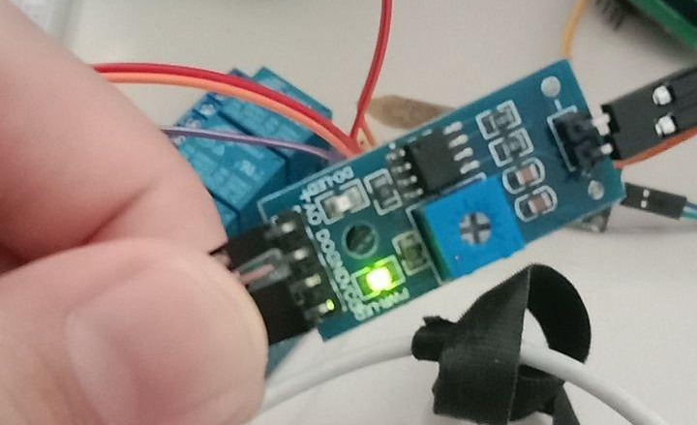
The LDR is able to measure light intensity in the incubator and send the data results to the ESP properly.

- HYGROMETER TEST
The hygrometer is able to work properly to measure soil moisture in the incubator and send its measurement data results to ESP.

- RTC TEST
The test results showed that the RTC is able to properly send time and date data to the ESP.

- RELAY TEST
The relay could not work properly so that the solenoid, fan and LED could not be used. We suspect that this is due to a fault in the connection cable. After we tried several times to reconnect the cables, we finally found an error in one of the installations and we fixed it.

- SOLENOID TEST
There was an error in the relay so that the solenoid could not release water. After the relay was repaired, fortunately the solenoid was able to function properly and there were no other problems.

- FAN TEST
Same with the solenoid, because the fan has a cable that is connected to the relay and there was interference with the relay, the fan couldn’t be turned on. After the relay is repaired, the fan can run smoothly because the problem lies only with the relay.

- LED TEST
There was an error in the relay connected to the LED which caused the LED not to light up. After the relay is repaired, the LED can light up brightly.

- LCD TEST
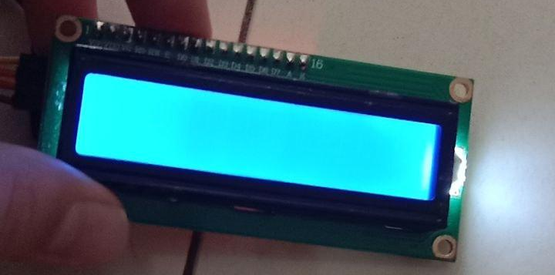
The LCD at first can work properly, but then suddenly it can't display the data from DHT, LDR, and hygrometer. After rechecking several times, apparently the LCD failed to display data because there was a deleted program. We then added the deleted program and luckily the LCD was working fine again.

4.5 FINAL DESIGN

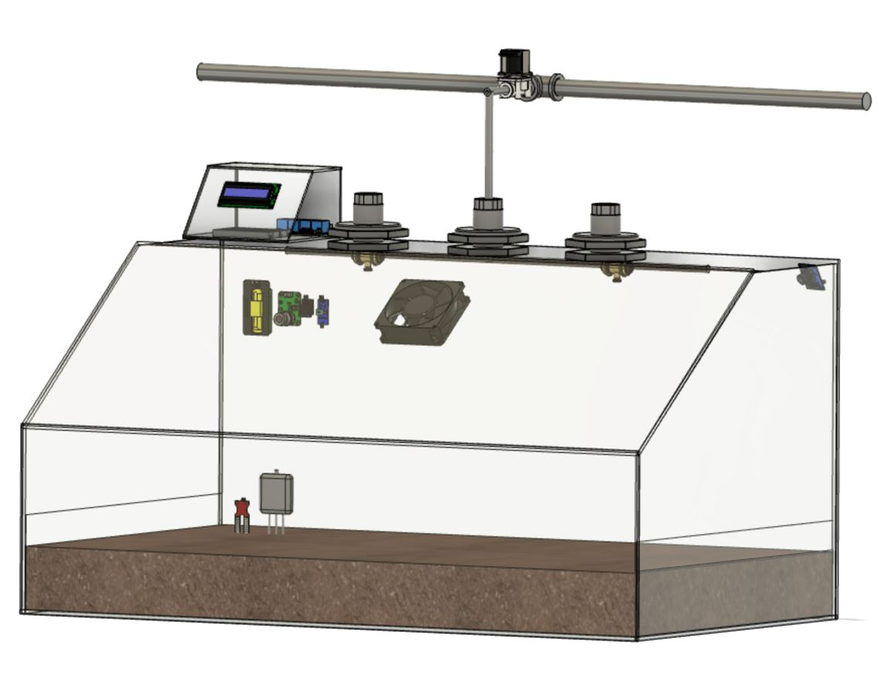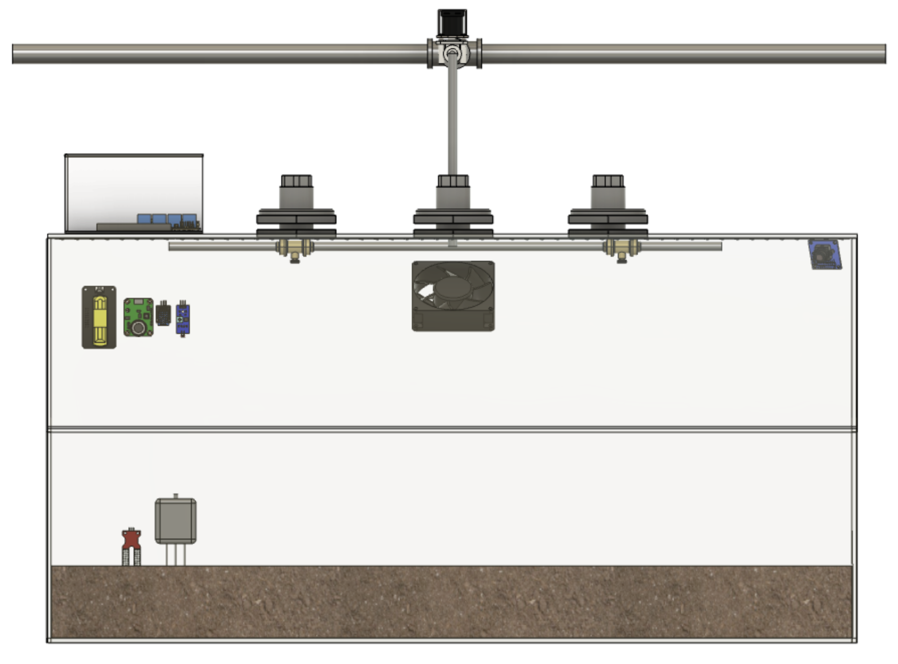
In the final design, there are 6 main functions namely; DHT which functions to measure temperature, LDR to measure light intensity, hygrometer which functions to measure the humidity of the planting medium, RTC which functions to display time and date data, automatic watering, maintaining humidity and temperature. The data that has been measured by the DHT, LDR, and hygrometer will be displayed on the LCD and also on the blynk. Solenoids, fans and LED lights are programmed to be able to respond to existing data so that the humidity and temperature in the incubator can be maintained stably.
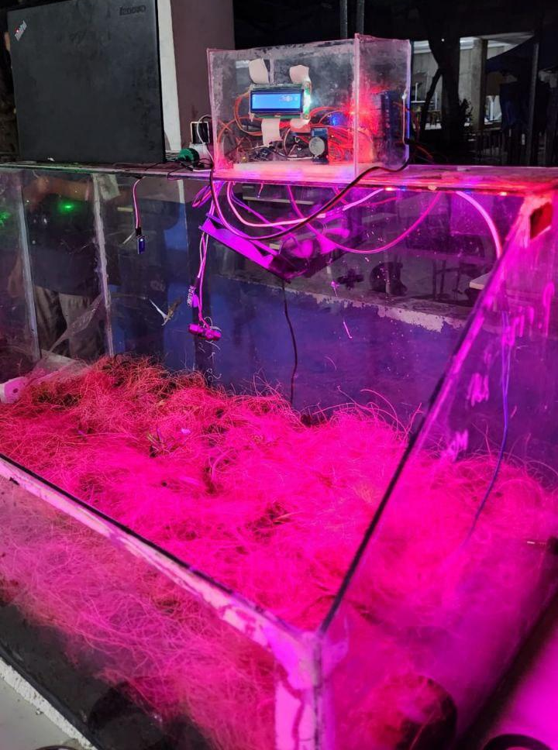
1
5

ARTWORK DESIGNS
5

- LOGO DESIGN


- BUSINESS PROPOSAL COVER DESIGNS



- PRODUCT BANNER DESIGNS

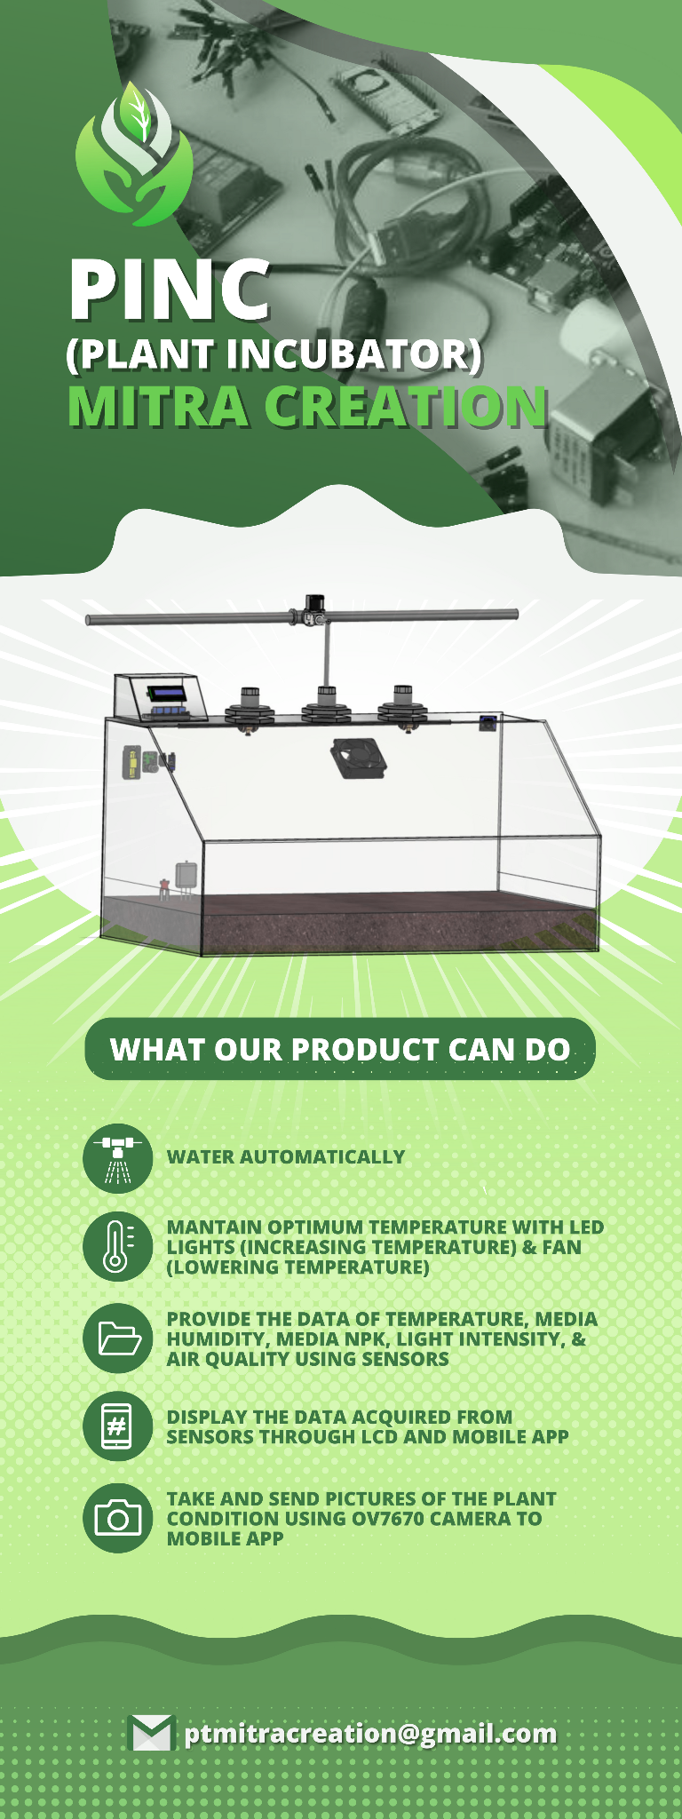

CONCLUDING REMARKS

Everything from design to programming and assembly has been carried out by our team, Mitra Creation, to produce the best smart plant incubator that meets the design requirements. The designed smart incubator has an automatic watering system and optimal temperature control with LED lights and a fan. Then, it is able to provide data related to air temperature, planting medium moisture, NPK content of the planting medium, light intensity, and air quality using sensors, as well as displaying those data through LCD and a mobile application. Lastly, the smart incubator can also take pictures of the plant condition using an OV7670 camera and send them to the mobile application.

Throughout the project work process, we faced difficulties because of the differences in each member. We all have different passions, opinions and ideas. When we need a solution to a problem, we must listen to each other's opinions and discuss them properly. Dividing tasks according to the ability of each member is also a difficult thing to do. Nonetheless, we always manage to get through every difficulty by working together because after all we have the same goal which is to give the best results we can.

In addition to learning to work together regardless of differences, we also learned to think under pressure and find solutions quickly. Due to the pile up of tasks and the number of members which is only 8 people, we learned to plan our schedule and work quickly but meticulously. We often feel tired and stressed, but we keep trying our best to reach the goal. We confirm and support each other in completing our respective responsibilities.

At the end of the day, we are very happy and grateful to have been brought together as a team and to have the opportunity to work together until the end. This smart plant incubator project taught us a lot and changed our perspective on many things. Thank you very much to the mentors who have guided us throughout the project.

